Sarah Ballinger
October 14, 1830 – February 14, 1901

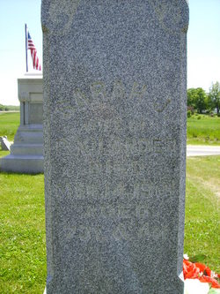
Photo by Jakesangel
No obit found at this time

