Eli Ballinger
August 17, 1863 – April 2, 1937

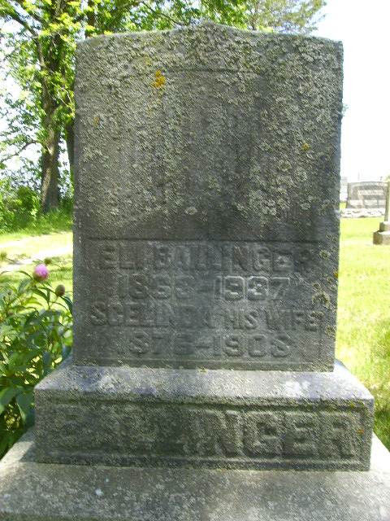
Photo by Jakesangel
Eli Ballinger
in the Indiana, Death Certificates, 1899-2011
Name: Eli Ballinger
Gender: Male
Race: White
Age: 73
Marital status: Widowed
Birth Date: 17 Aug 1863
Birth Place: Indiana
Death Date: 2 Apr 1937
Death Place: Hartford, Blackford, Indiana, USA
Parents: Unknown
Informant: Hulda Summers, Dayton, Ohio
Burial: April 4, 1937; Asbury Chapel

