Elgenia Ballinger
January 5, 1872 – January 31, 1893

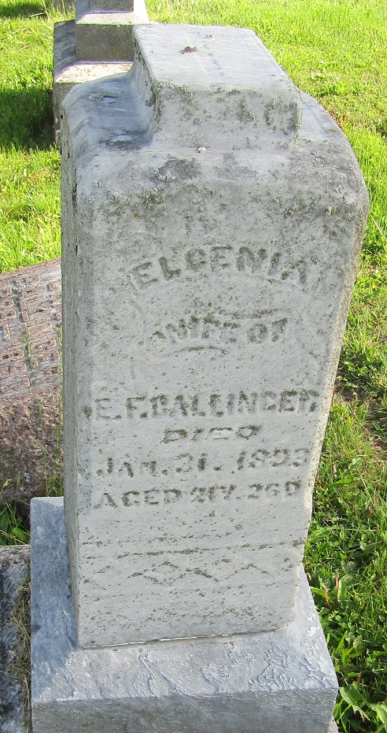
Mrs. Eli Ballinger died very suddenly at her home near Roll Monday at midnight. She had been troubled with dropsy and her lungs and throat had become affected. She prepared the evening meal Monday and appeared to be no worse than for some time. Physicians attributed her sudden death to choking.
The deceased was twenty-three years of age. She leaves a disconsolate husband with two small children. Burial at Asbury Chapel Wednesday.
Hartford City Telegram, Blackford County, Ind.
Thursday, February 2, 1893

