Nathaniel Calvin Alspach
June 24, 1857 – January 21, 1917

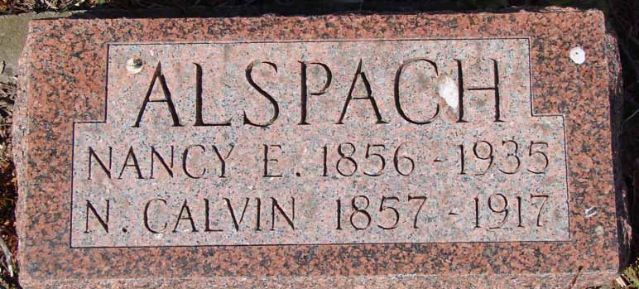
Photo by Ron Oswalt

Calvin Alspaugh
in the Indiana, Death Certificates, 1899-2011
Name: Calvin Alspaugh
Gender: Male
Race: White
Age: 59
Marital status: Married
Birth Date: 24 Jun 1887
Birth Place: Indiana
Death Date: 21 Jan 1917
Death Place: WA??, Indiana , USA
Father: Amos Alspaugh
Mother: Elizabeth
Spouse: Nancy
Burial: Jan. 23, 1917; Asbury Chapel Cemetery

