James Alexander
August 28, 1827 – March 30, 1900

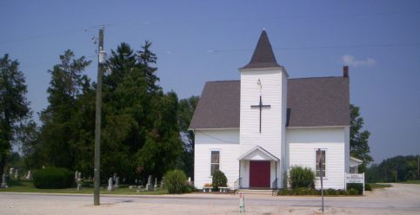
Photo by Ron Oswalt

James Alexander
in the Indiana, Death Certificates, 1899-2011
Name: James Alexander
Gender: Male
Race: White
Age: 72 years, 7 months, 2 days
Marital status: Married
Birth Date: abt 1828
Birth Place: Logan Co., Ohio
Death Date: 30 Mar 1900
Death Place: Montpelier, Blackford, Indiana, USA
Father: Robert Alexander
Mother: Mary Wilkinson
Informant: J. Sellers, Montpelier
Burial: April 2, 1900; Wells Co.

