Edward Alexander
August 8, 1809 – March 2, 1884

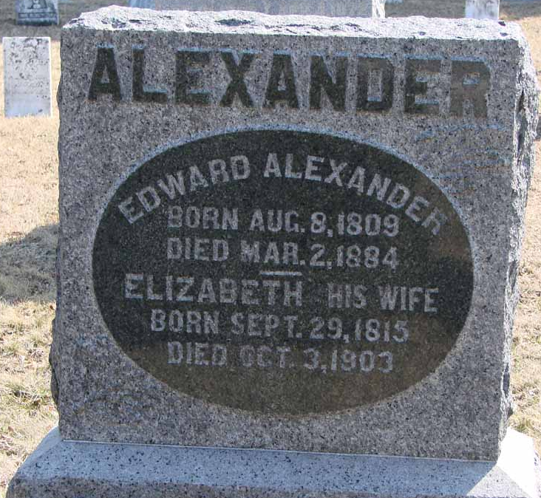
Photo by Ron Oswalt

No obit found at this time

