Commodore Alexander
March 13, 1847 – August 25, 1914

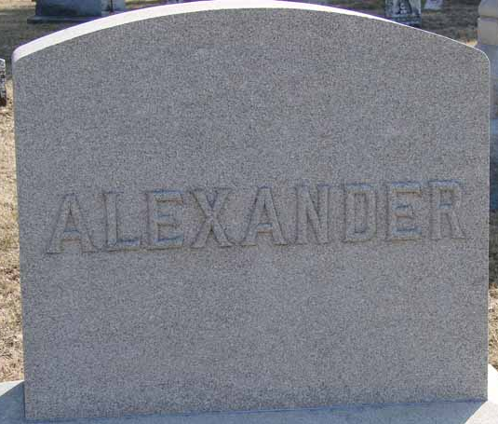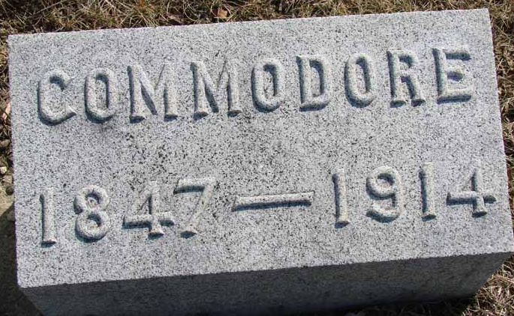
Photo by Ron Oswalt

Commodore Alexander
in the Indiana, Death Certificates, 1899-2011
Name: Commodore Alexander
Gender: Male
Race: White
Age: 67
Marital status: Married
Birth Date: 13 Mar 1847
Birth Place: Indiana
Death Date: 24 Aug 1914
Death Place: Washington, Blackford, Indiana, USA
Father: Edward Alexander
Mother: Frances
Informant: Evert Alexander, Roll, Ind.
Burial: Aug. 27, 1914; Asbury Chapel

