Anna Catharine (Smithgall) Alexander
March 6, 1864 – August 7, 1949

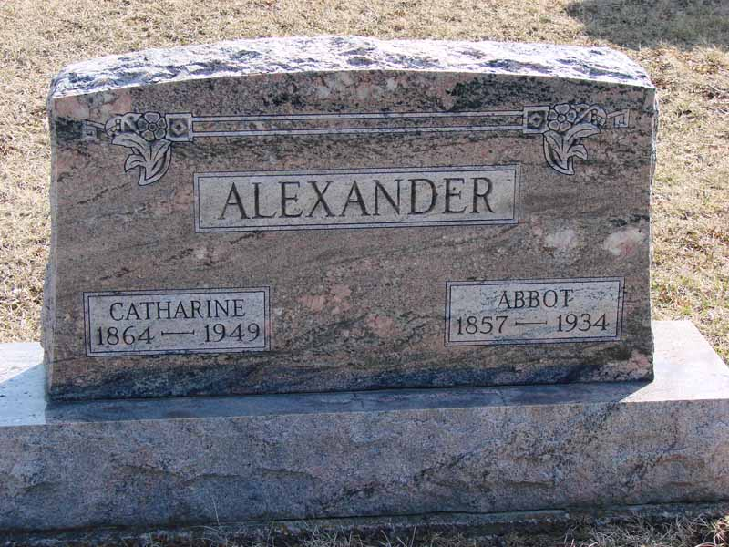
Photo by Barbara Baker Anderson

Catherine Alexander
in the Indiana, Death Certificates, 1899-2011
Name: Catherine Alexander
Gender: Female
Race: White
Age: 85
Marital status: Widowed
Birth Date: 6 Mar 1864
Birth Place: Wells Co Indiana
Death Date: 7 Aug 1949
Death Place: Montpelier, Wells, Indiana, USA
Father: Abbot Alexander [sic]
Mother: Elizabeth Colbert
Informant: Claud Alexander; Montpelier RR
Burial: Aug. 9, 1949; Asbury, Montpelier RR

