Alice L. (Schwartz) Steffen
February 18, 1923 – September 13, 2009

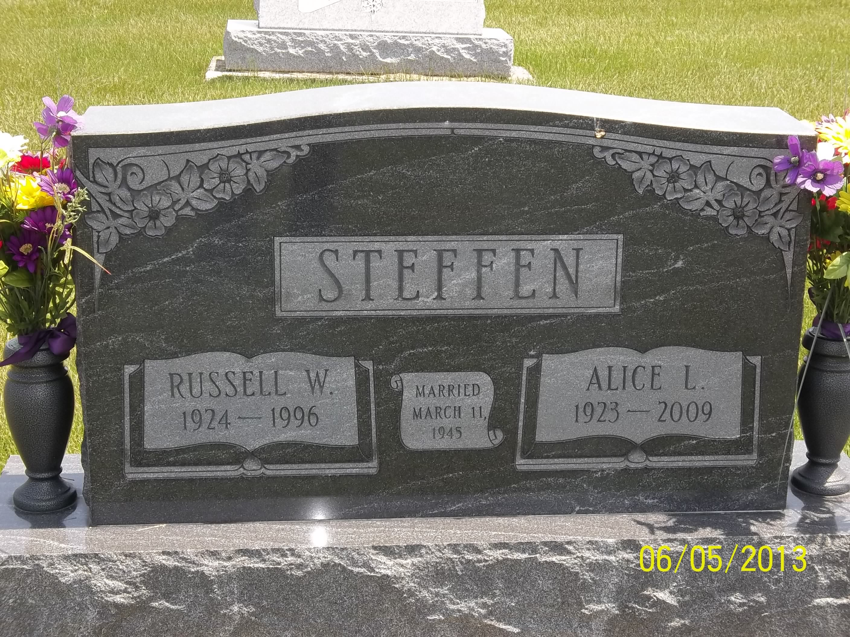
Photo by Danielle Brooks

Alice L. Steffen, 86, Bluffton, died at 12:54 p.m. Sunday, Sept. 13, 2009, at the Bluffton Regional Medical Center.
Mrs. Steffen was a housewife, and had also been employed at Franklin Electric. She was a member of the Apostolic Christian Church. She was born Feb. 18, 1923, in Wells County, to Levi and Sarah Reinhard Schwartz. She married Russell W. Steffen March 11, 1945, in Bluffton. Her husband preceded her in death Oct. 22, 1996.
Survivors include two children, Bill (Donna) Steffen of Bluffton and Sandy Moffett of Greenwood; four grandchildren and two great-grandchildren; and a sister, Ada (Harry) Gerber of Bluffton.
She was preceded in death by four brothers, Ervin R. Schwartz, Ralph Schwartz, Harry Schwartz, and Edward Schwartz Sr., and two sisters, Martha Gerber and Lula Baumgartner.
Calling will be from 6 to 8 p.m. Monday and from 1 to 8 p.m. Tuesday at the Goodwin Memorial Chapel in Bluffton. There will be additional calling from 9:30 to 10:30 a.m. Wednesday at the Apostolic Christian Church East. Services will be held at 10:30 a.m. Wednesday at the church with Gary Tonner and Nile Bucher officiating. Burial will be at the Apostolic Christian Cemetery. Preferred memorials are to the Christian Care Retirement Community or to the church.
Goodwin-Cale & Harnish Memorial Chapel online obit (accessed 6/14/2017)

