Sally J. (Ross) Schwartz
April 25, 1934 — October 7, 2026

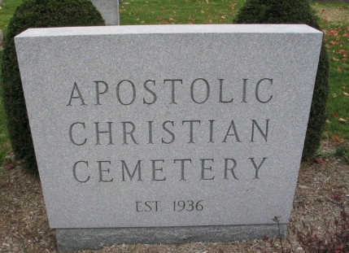
Photo by Barbara Baker Anderson

Sally J. Schwartz, 92, of Berne, Indiana, went home to be with her Lord and Savior on Wednesday afternoon, October 7, 2026, surrounded by her family at Swiss Village. She was born on April 25, 1934, in Rantoul, Illinois, to the late Ralph Ross Sr. and Glenna (Bradley) Ross. Sally married Lester W. Schwartz on April 25, 1953, and he preceded her in death on April 3, 2017.
Sally was a member of the Apostolic Christian Church. Throughout her working life, she held positions at G.E. in Decatur and Nussbaum Novelty in Berne. She also spent 28 years co-owning Schwartz Marathon with her husband, Les, and later worked at Berne's C&R Design.
She was a gifted cook and seamstress who maintained a large garden each year to provide produce for her family as they grew. She loved traveling and birdwatching alongside Les. Above all, she supported her grandchildren by attending their sporting events.
Sally is survived by her son, Scott (Patti) Schwartz of Berne, Indiana; son, Steve (Julie) Schwartz of Bluffton, Indiana; daughter, Sue (Terry) Lehman of Berne, Indiana; brother, Daniel (Bette) Ross of Decatur, Indiana; brother, John Ross of Florida; seven grandchildren, Kyle (Kyann) Schwartz, Ryan (Mandy) Schwartz, Curtis Schwartz, Christopher Schwartz, Kennan Schwartz, Mandy (Daniel) Hunley, and Jill (Isaac) Akins; and 14 great-grandchildren, Delaney, Joel, Grant, Brody, and Meredith Schwartz, Caleb, Spencer, and Karlee Schwartz, Brockton Osborne, Addisyn and Noah Hunley, Piper, Bria, and Bo Akins.
She was preceded in death by her four brothers, Ralph “Sonny” Ross Jr., Kenneth Ross, William Ross, and Michael “Duke” Ross.
A funeral service will be held at 2:00 p.m. on Monday, October 12, 2026, at the Swiss Village Chapel in Berne, Indiana, with Lynn Fiechter and Kole Meyer officiating. Burial will follow at the Apostolic Christian Cemetery in rural Adams County, Indiana. The family will receive friends from 12 noon to 2:00 p.m. on Monday, October 12, 2026, at the Swiss Village Chapel in Berne, Indiana. Preferred memorials can be given to the Swiss Village Samaritan Fund.

Zwick & Jahn Funeral Homes, Adams County, Indiana
October 12, 2026

