Everett L. Schladenhauffen
April 6, 1920 – September 12, 2007

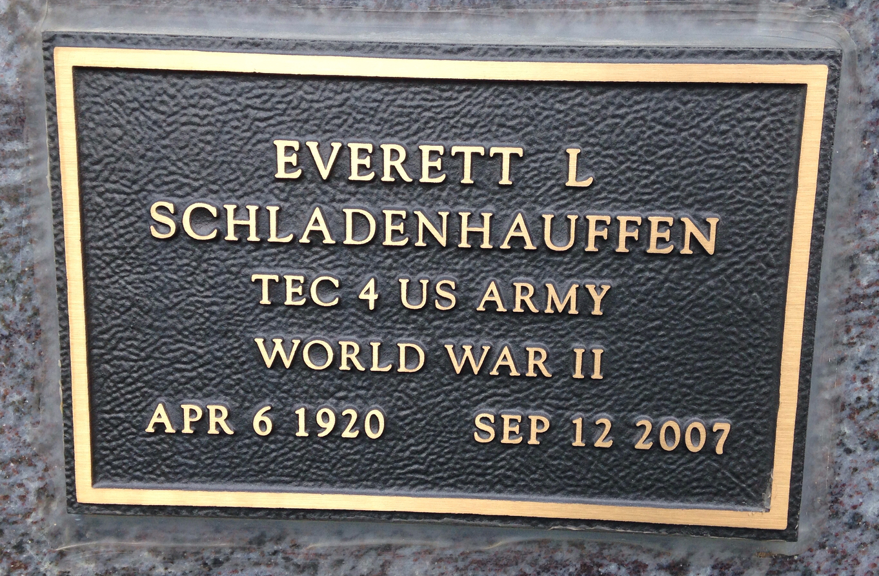
Photo by Barbara Baker Anderson

Everett L. Schladenhauffen, 87, of Bluffton, died at 5:20 a.m. Wednesday, Sept. 12, 2007, at his residence.
Born in Kirklin Township in Adams County to Emil and Lillie (Feisley) Schladenhauffen on April 6, 1920, Mr. Schladenhauffen married Luella M. Gerber in Bluffton on April 21, 1946; she survives.
A 1939 graduate of Kirklin Township High School, Mr. Schladenhauffen served with the U.S. Army for four years during World War II, and worked as a self-employed in floor covering installation. He was a member of the Apostolic Christian Church.
Other surviving relatives include one daughter, Luann Brock of Tampa, Fla.; three sons, Gary (Nancy) Schladenhauffen of Craigville, Mark (Sue) Schladenhauffen of Pietermaritzburg, South Africa and Keith (Delores) Schladenhauffen of Francesville; two brothers, Warren Schladenhauffen of Garrett and Harold Schladenhauffen of Bluffton; nine grandchildren and three great-grandchildren.
He was preceded in death by three brothers, Amos, Charles and Sam Schladenhauffen, and three sisters, Clara Fiechter, Esther Schliman and Edith Stultz.
Funeral services will be at 10 a.m. Saturday at the Bluffton North Apostolic Christian Church with Nile Bucher and John Reinhard officiating. Calling hours will be from 2 to 8 p.m. Friday at Goodwin Memorial Chapel, and for one hour prior to service at the church. Burial will be at the Apostolic Christian Cemetery. The American Legion will conduct the committal service.
Preferred memorials are to Christian Care Retirement Center or Alzheimer's Association.
Bluffton News-Banner, Wells County, IN; Thursday, Sept. 13, 2007

