George Ringger
March 24, 1931 – January 2, 2026

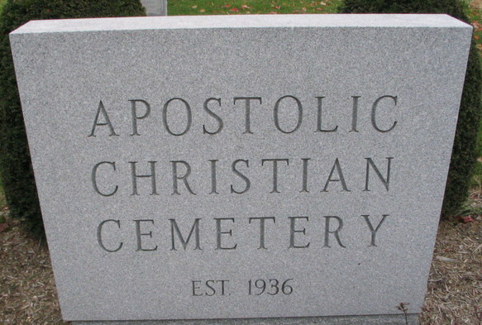
Photo by Barbara Baker Anderson

George Ringger, 94, of rural Bluffton, Indiana, peacefully went home to be with his Lord and Savior surrounded by his family Friday evening, January 2, 2026, at his residence. He was born on March 24, 1931, to the late George and Leah (Steffen) Ringger, Sr. in Adams County, Indiana. George married Evelyn J. Pfister on February 19, 1956, at the Bluffton Apostolic Christian Church, celebrating nearly 70 years of marriage.
George honorably served his country in the United States Army during the Korean Conflict.
He began his repentance with the Lord and was baptized in the Bluffton Apostolic Christian Church on December 10, 1955, and was a lifelong faithful member of the Apostolic Christian Church. He served as an usher for many years and truly loved those years of service.
George graduated high school in 1949 the last graduating class of Kirkland High School. Throughout his life, he specialized in sales for various companies.
He never met a stranger and truly had a heart and love for people. George truly loved his family and cherished all the time spent together.
George is survived by his wife of 69 years, Evelyn Ringger of Bluffton, Indiana; daughter, Holly (Dean) Frauhiger of Bluffton, Indiana; daughter, Val (Jeff) Leman of Craigville, Indiana; son, Von (Kathy) Ringger of Northville, Michigan; son, Dale (Amy) Ringger of Wyoming, Illinois; brother, William “Bill” Ringger; sister, Lillian Yergler; brother, Alvin “Al” (Colleen) Ringger; sister-in-law, Lucy Isch all of Bluffton, Indiana; sister-in-law, Rosie Gramm of Gridley, Illinois; 16 grandchildren, Krent (Liz) Frauhiger, Erin (Joel) Drayer, Joe (Lisa) Leman, Shawn (Kara) Leman, Brad (Charla) Leman, Adam (Jenna) Leman, Mary (Jacob) Schlipf, Lauren (Elliott) Laughlin, Blake Ringger, Paige (Colten) Tennison, Ryan (Laura) Johnson, Holly (Matt) Sinco, Andrew Johnson, Jonathon (Jessi) Johnson, Serenity (Kevin) Nohl, Jasmine Ringger, Eli (Sheila) Ringger, Gideon (Julie) Ringger, Boaz (Gloria) Ringger, and Hogan (Abigail) Ringger; and 59 great-grandchildren.
He was preceded in death by five brothers, Raymond, Orville, Reuben, Arthur, and Sylvan “Sib”Ringger; and two sisters, Mary Frauhiger and Ida Aschliman.
A funeral service will be held at 10:30 a.m. Saturday, January 10, 2026, at the Bluffton Apostolic Christian Church – East with Jeff Leman and Vince Pfister officiating. Burial will follow at the Apostolic Christian Cemetery in rural Adams County, Indiana, with military honors being rendered by the United States Army Honor Guard in conjunction with the Bluffton American Legion Post #111. Visitation will be from 2:00 to 8:00 p.m. Friday, January 9, 2026, at the Bluffton Apostolic Christian Fellowship Hall in Bluffton, Indiana, and from 9:30 to 10:15 a.m. Saturday, January 10, 2026, prior to the service at the church.
Preferred memorials can be given to the Apostolic Christian Church.

Zwick & Jahn Funeral Home, Adams County, Indiana
January 2, 2026

