Betty Jane (Reinhard) Macklin
October 28, 1932 – October 17, 2026

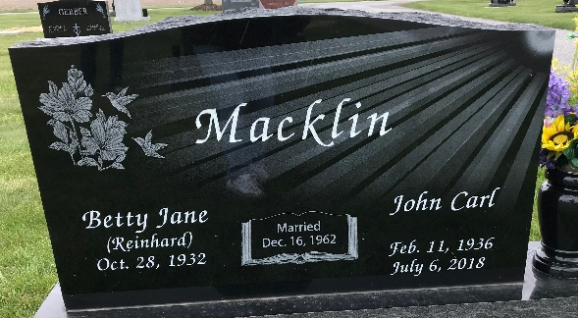
Photo by Sherry

Betty Jane Macklin, 93, of rural Bluffton and formerly of Ossian, passed away Saturday evening, October 17, 2026, at her daughter’s residence.
Betty was born in Bluffton on October 28, 1932, to Ezra and Delva (Aschliman) Reinhard, Sr. She married John “Carl” Macklin in Ossian on December 16, 1962. He preceded her in death on July 6, 2018.
Betty attended Lancaster School and attended the Apostolic Christian Church. She was a lifelong farmer and worked for Franklin Electric as a tool and die machinist for nearly 40 years.
She loved her flowers, gardening, and selling produce at farmers’ markets in various surrounding counties. She enjoyed helping many family members trim and paint the inside of their homes. She was an avid auction attender; she would visit the weekly livestock sales in Geneva often taking an animal to sell and returning home with a different animal. She raised horses, pigs, sheep, chickens, and dogs.
But one of her biggest joys was raising her children and lovingly caring for her grandchildren and her great-grandchildren. Betty and Carl made it a priority to attend nearly every sporting event of her children and grandchildren. She enjoyed fishing, but rarely got the chance to do so, because she was never able to find the time. Betty was always sharing her produce and time with those she loved. In her later years, Betty loved the time she spent with her family and especially brightened up when holding her grandchildren and great-grandchildren.
Betty is survived by two daughters, Debra (Brian) Fiechter of Bluffton and Connie (Rod) Bucher of Cicero; two sons, Alan Macklin of Van Wert, OH, and Ronnie (Lanae) Macklin of Bluffton; a sister, Edna Moser; a brother, Daniel Reinhard; 14 grandchildren, Nichole (Tony) Raber, Ashley (Jason) Gerber, Ethan (Whittney) Fiechter, Zach (Taylor) Fiechter, Brock (Brooke) Bucher, Brody (Ashley) Bucher, Brooke Bucher, Brittany (Evan) Carr, Benji (Ruthie) Bucher, Olivia (Matt) Kaehr, McKenna (Ben) Fiechter, Logan (Ciera) Macklin, Ava (Corbin) Hirschy, and Owen Macklin; along with 27 great-grandchildren and one on the way.
In addition to her husband and parents, Betty was preceded in death by four sisters, Mildred Badiac, Aldulla Pulver, Loretta Reinhard, and an infant sister Rose Reinhard; five brothers, Harry, Ezra Jr., Jim, Kenneth and Dale Reinhard; along with a grandson Adam Fiechter.
Visitation will be Wednesday, October 21, 2026, from 3:00 until 8:00 PM, at Goodwin – Harnish Funeral Home in Bluffton. Services will be held on Thursday, October 22, 2026, at 10:30 AM, at the Apostolic Christian Church East, with one hour of visitation prior to the service. Lynn Fiechter and Chad Gerber will officiate. Burial will follow at the Apostolic Christian Cemetery in Adams County.
Memorial contributions may be directed to Stillwater Hospice or Christian Care Retirement Community.

Goodwin Funeral Homes, Wells County, Indiana
October 18, 2026

