Lou (Meyer) Klopfenstein
January 11, 1913 – September 16, 2000
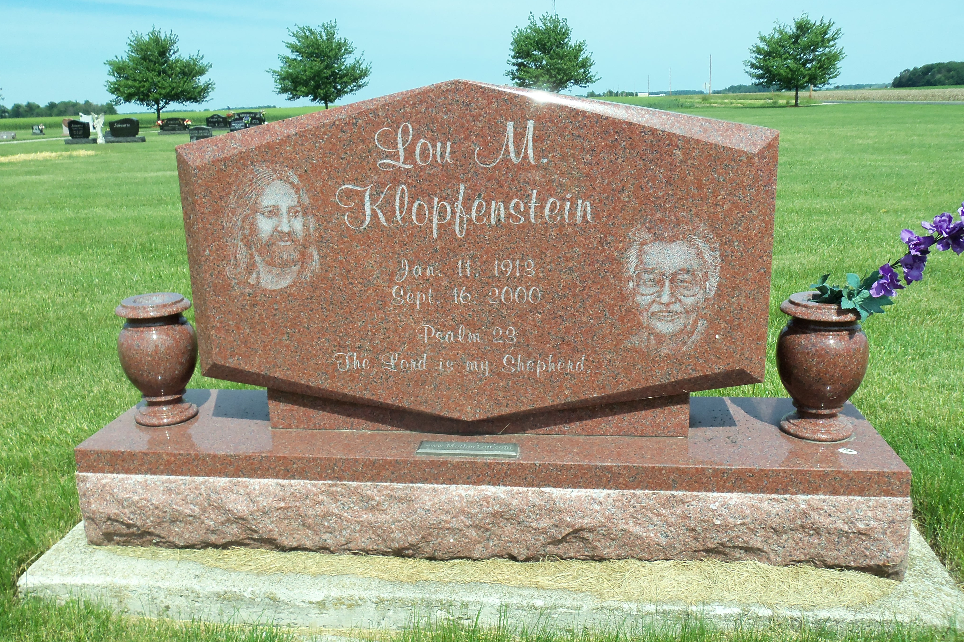
Photo by Deb Curry
Lula M. Klopfenstein, 87, a native of Wells County, died at 10 a.m. Saturday in Okeechobee, Fla., where she had resided since December 1995.
A homemaker, Mrs. Klopfenstein was born Jan. 11, 1913 to Albert and Sarah Schwartz Meyer. Her marriage at Bluffton on Nov. 3, 1940 was to Harold Klopfenstein, who died Jan. 1, 1991.
Mrs. Klopfenstein was a member of the End Time Gospel Church in Fort Wayne.
Surviving are two sons, Sidney of Tequesta, Fla., and Chuck of Okeechobee, Fla.; two daughters, Mrs. Tom (Mary Lou) Dillard of Angola and Lois Falk of Okeechobee; six grandchildren; and five great-grandchildren. Two brothers and three sisters are deceased.
Services will be at 10:30 a.m. Saturday, Sept. 23, at the End Time Gospel Church in Fort Wayne with Rev. Tom Dillard officiating. Burial will be in the Apostolic Christian Church Cemetery at Vera Cruz. Visitation times will be at Thoma/Rich, Hewitt & Chaney Funeral Home in Bluffton from 7 to 9 p.m. Thursday and from 10 a.m. to 9 p.m. Friday.

The News-Banner, Bluffton, Indiana, Wells County, IN; September, 2000

