Velma Viola (Fiechter) Kipfer
December 10, 1918 – August 29, 1976

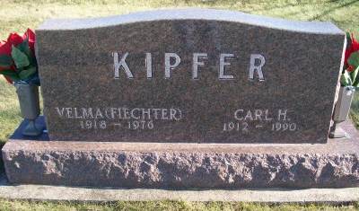
Photo by Scott Shoup

Wife of Carl Kipfer Dies

Mrs. Velma Kipfer, 57, wife of Carl Kipfer of Berne Route 1, died at 11:18 p.m. Sunday at Clinic Hospital. Death followed an illness of three months.
Born Dec. 10, 1918 in Wells County, she was a daughter of John J. and Lydia Gerber Fiechter. Her marriage to Mr. Kipfer took place July 14, 1946 in Wells County.
Mrs. Kipfer, a lifelong resident of Wells and Adams Counties, was a member of the Apostolic Christian Church.
Surviving, in addition to the husband, are a son, Ronald Lee of Peoria, Ill.; two daughters, Mrs. Allen (Beverly) Hodel of Lima, O., and Joleen Kay, at home, and one granddaughter.
Four brothers, Ervin Fiechter of Bluffton Route 4, Dale Fiechter of Ossian Route 2 and John and Gerald Fiechter, both of Craigville Route 1, and six sisters, Mrs. Aaron (Irene) Reinhard of Craigville Route 1, Mrs. Herman (Marie) Drayer of Ossian Route 1, Mrs. Millard (Alice) Aschliman of Decatur Route 4, Mrs. William (Mildred) Neuensch-wander and Mrs. Walter (Lillian) Bertsch, both of Bluffton Route 4, and Mrs. Charles (Doris) Neuenschwander of Morristown, also survive.
Calling will be after 7 p.m. today at the Goodwin Memorial Chapel. The body will be taken at 12:30 p.m. Wednesday to the Apostolic Christian Church for services at 1:30 p.m., ministers of the church officiating.
A preferred form of material is a contribution to the Children’s Home at Leo or the Handicapped Home at Morton, Ill.

Unknown newspaper clipping

