Lucille (Neuenschwander) Kaehr Grandlienard
July 2, 1922 – February 15, 2015
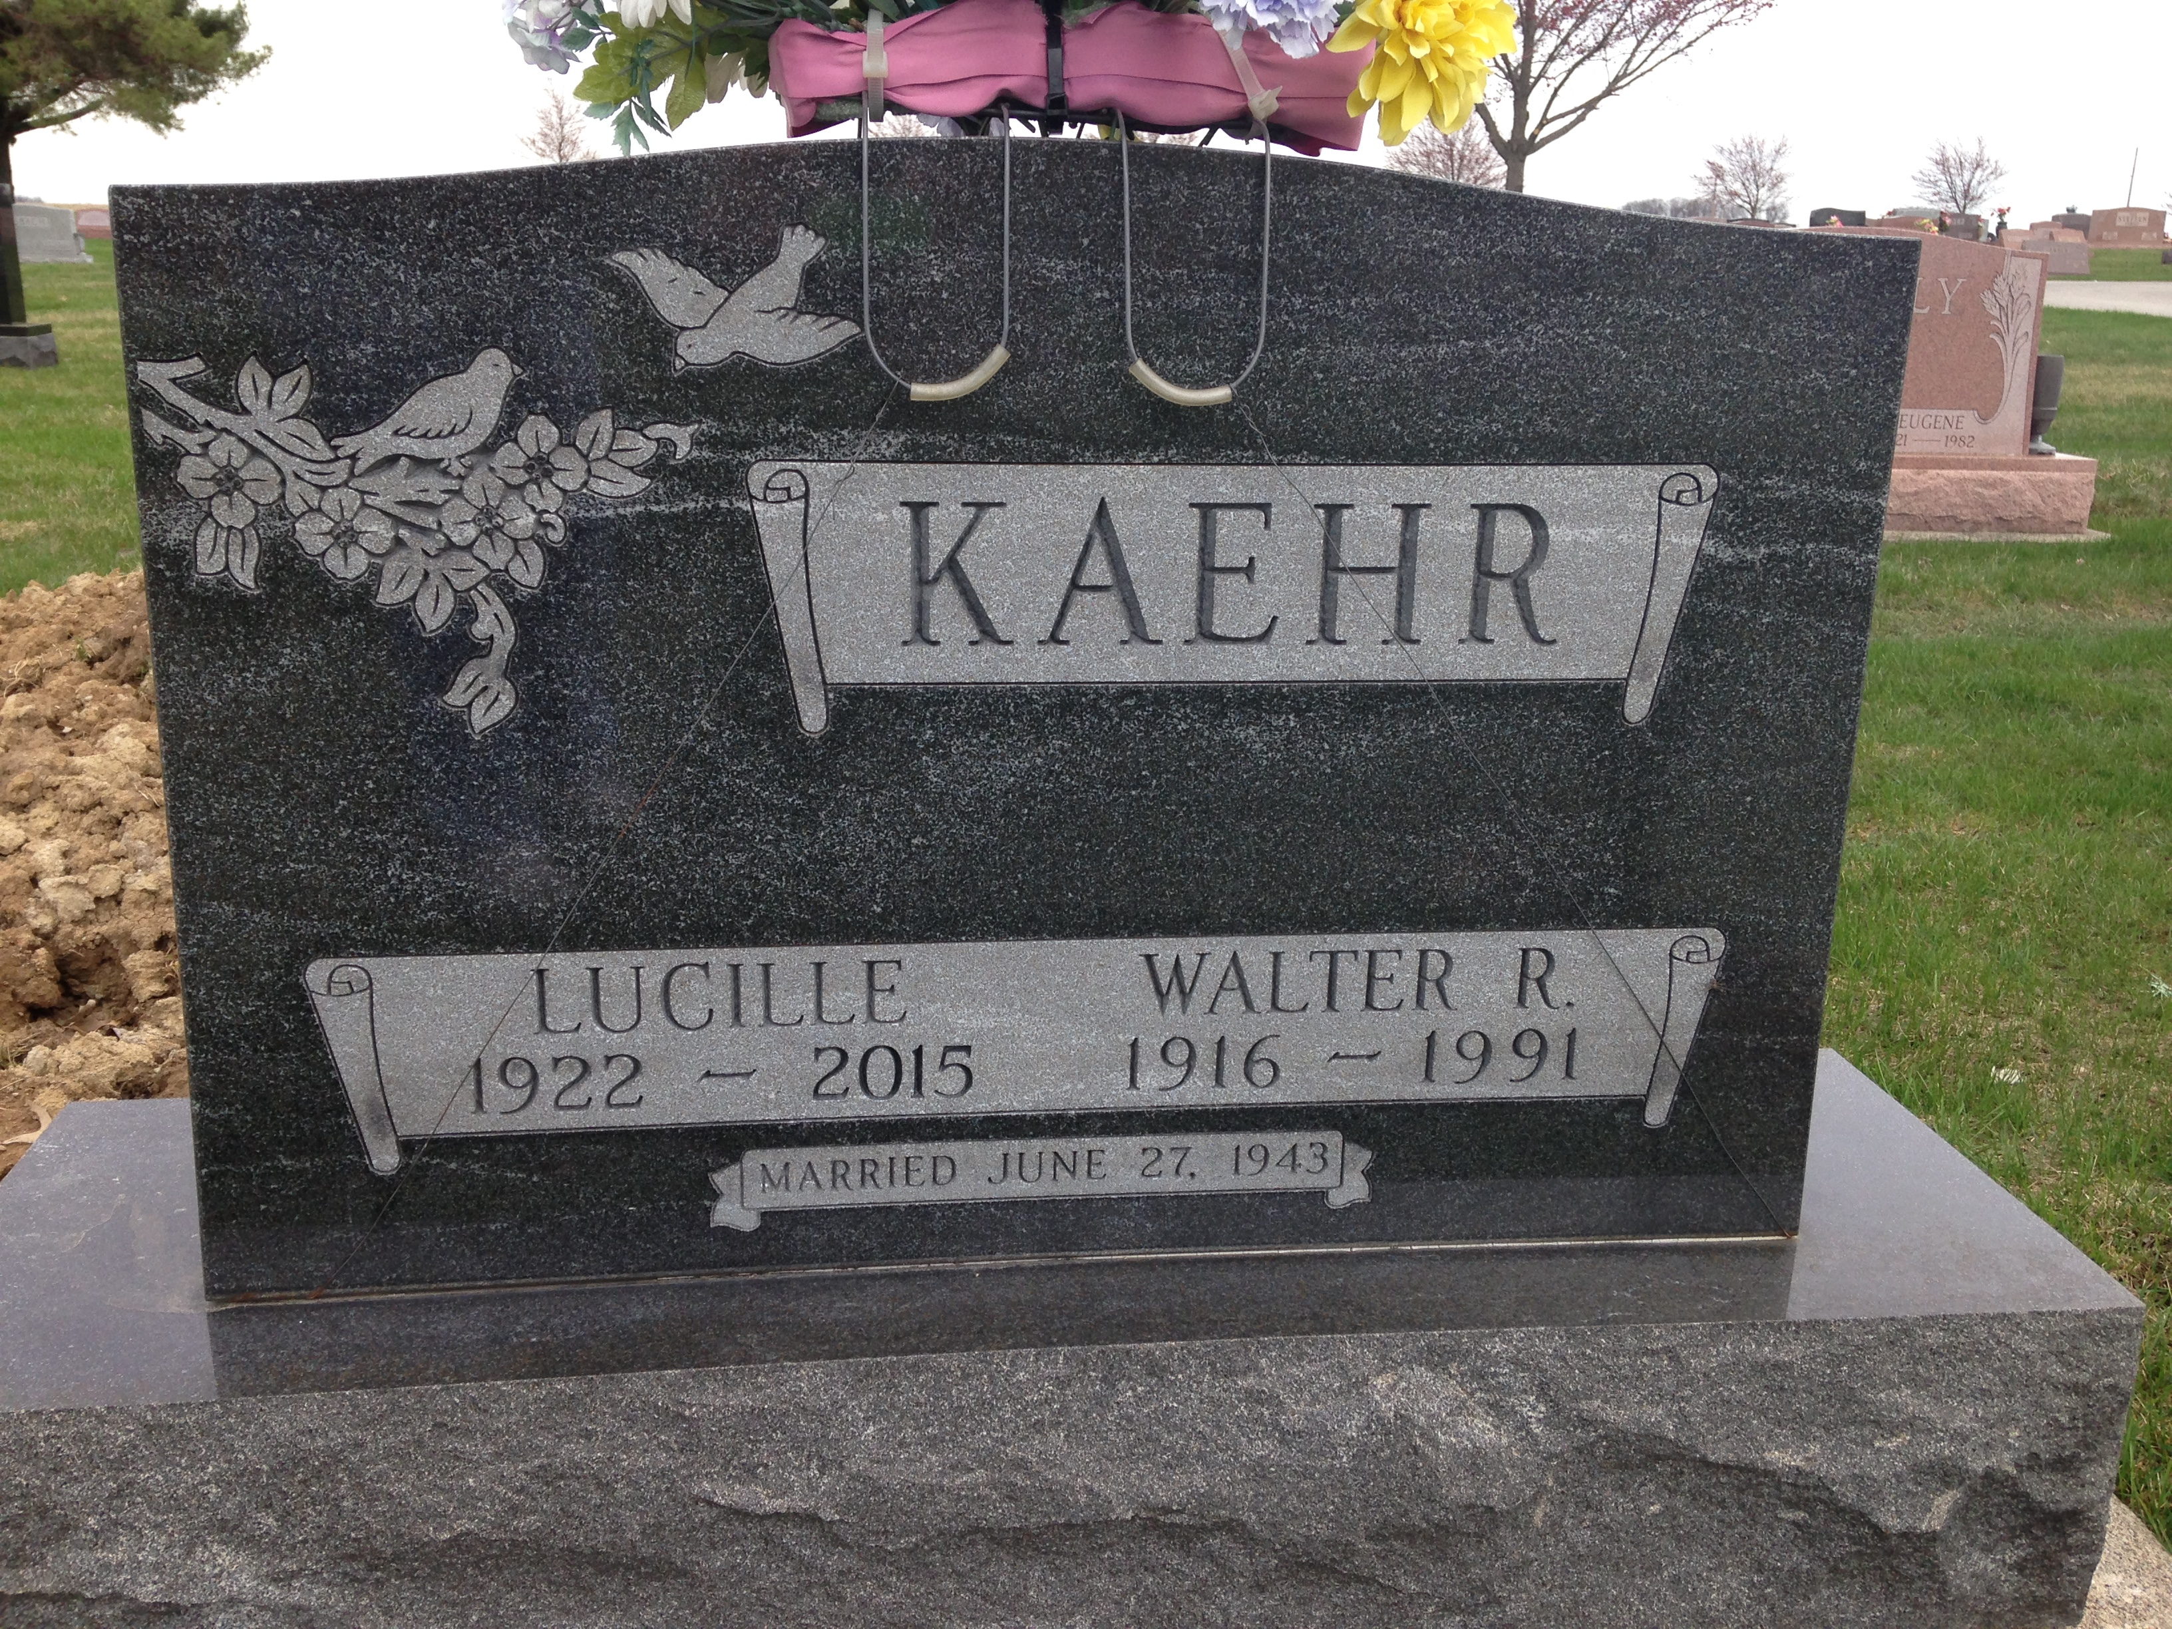
Photo by

Lucille “June” Kaehr Grandlienard, 92, died Sunday, Feb. 15, 2015, at Christian Care Retirement Center in Bluffton.
She was born July 2, 1922, in Wells County to William G. and Elizabeth (Schwartz) Neuenschwander. Her first marriage was to Walter R. Kaehr June 27, 1943; he preceded her in death. She married Leonard P. Grandlienard Nov. 15, 1995; he preceded her in death.
She worked as head waitress at the Dutch Mill restaurant in Bluffton for 13 years and also was a homemaker. She was a member of the Apostolic Christian Church. Lucille loved flowers and gardening, and cooking for her family.
Survivors include sons Jim (Marcia) Kaehr of Lagro and Keith (LouAnn) Kaehr, of Decatur; a daughter, Rita (Dick) Everett of Bluffton; a daughter-in-law, Fern Kaehr of Lyden, Wash.; stepchildren, Karen D. Kipfer of Lima, Ohio, and Elane (James) Lawson, of North Carolina; a brother, Charles “Chuck” (Doris) Neuenschwander; two sisters, Betty (William “Bill”) Frauhiger and Joyce (Howard) Baumgartner, both of Bluffton; a sister-in-law, Irene Neuenschwander, of Bluffton; 15 grandchildren; 21 great-grandchildren; two step-great-granddaughters; an a step-great-grandson.
Preceding her in death were a son, Ron Kaehr; three brothers, Walter, Bill and John Neuenschwander; and five sisters, Virgil Isch, Ellen Fiechter, Ann Frauhiger, Ada Gerber and Martha Heyerly.
A service will be held at 10:30 a.m. Friday, Feb. 20, at Apostolic Christian Church East, with Steve Frauhiger and Doyle Frauhiger officiating. Visitation will be from 1 to 8 p.m. Thursday, Feb. 19 at Goodwin-Cale & Harnish Memorial Chapel and one hour prior to the service Friday at the Church.

