Harry A. Isch
May 3, 1917 – July 8, 2014

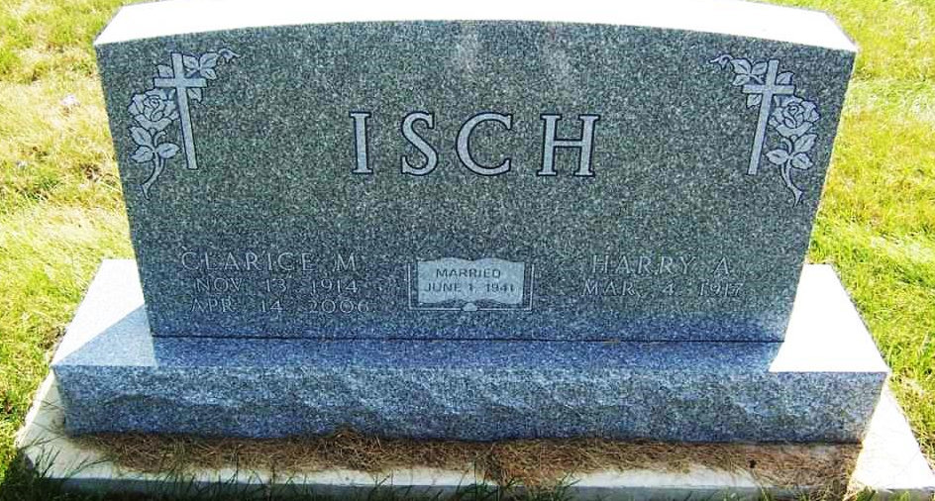
Photo by Pretty Little Grave Seekers

Harry A. Isch, 97, of Bluffton, passed away Tuesday, July 8, 2014, at Christian Care Retirement Community.
Harry was born May 3, 1917, in Wells County to John and Katie Steffen Isch. He married Clarice M. Mangold June 1, 1941, in Roanoke, Ill.
He was the owner of Isch Hardware for more than 40 years and he was a member of the Apostolic Christian Church.
Survivors include a son, Dr. John (Mary) Isch of Carmel; two daughters, Catherine (Keith) Steffen of Washington, Ill. and Constance (William) Witzig of Indianapolis; 10 grandchildren; 33 great-grandchildren; and a brother, Roger Isch of Bluffton.
He was preceded in death by an infant daughter, Ann Catherine Isch and a sister, Helen Gerber.
Services will be held at 10 a.m. Friday, July 11, at the Bluffton North Apostolic Christian Church with Nile Bucher and Mark Gerber officiating. Calling hours are from 2 p.m. to 8 p.m. at the Goodwin-Cale & Harnish Memorial Chapel and one hour prior to the service Friday at the church. Burial is at the Apostolic Christian Cemetery.
Memorials may be made to the Good Samaritan Fund at Christian Care Retirement Community or World Relief Fund c/o Apostolic Christian Church.
Online condolences at: www.thegmcfamily.com

Goodwin-Cale & Harnish Memorial Chapel online obit (accessed 3/9/2017)

