Rosella L. Heyerly
April 4, 1926 – September 4, 2019

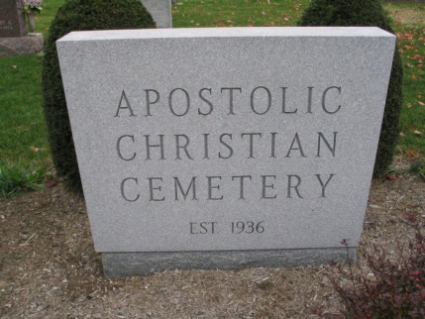
Photo by Barbara Baker Anderson

Rosella L. “Rosie” Heyerly, age 93, of Bluffton, passed away Wednesday morning, Sept. 4, 2019, at Christian Care Retirement Community.
Rosie was born in Adams County on Apr. 4, 1926, to Albert and Aldine (Aschliman) Heyerly. Both parents preceded her in death.
A 1944 graduate of Kirkland High School, Rosie was a lifelong member of the Apostolic Christian Church. She worked as an Avon saleslady for 50 years. Rosie enjoyed playing the piano and mandolin. She loved to cook and sing with her family. She also enjoyed her garden and canning the produce.
Survivors include a brother, Simon “Pete” (Delores) Heyerly of Bluffton; along with many nieces and nephews.
In addition to her parents, Rosie was preceded in death by five brothers, Luster, Clifford, Herman, Ray, and Homer Heyerly; and six sisters, Jeanette Tonner, Berniece Maller, Alice Gerber, Ada Gerber, Gladys Gerber, and Dula Heyerly.
Visitation will be Friday, Sept. 6, 2019, from 4:00 until 7:00 PM, at Goodwin – Cale & Harnish Memorial Chapel in Bluffton. Services will be Saturday, Sept. 7th, at 10:30 AM, at the Apostolic Christian Church East, with one hour of visitation prior to the service at the church. Troy Leyse and Mark Gerber will officiate. Burial will follow at Apostolic Christian Cemetery in Adams County.
Memorials can be made to Christian Care Retirement Community or Apostolic Christian Harvest Call.

Goodwin Funeral Homes, Wells County, Indiana
Wednesday, September 4, 2019

