Amelia M. (Ringger) Heyerly
July 26, 1915 – March 24, 2006

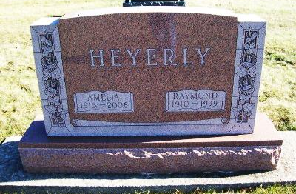
Photo by Scott Shoup

Services will be at 2 p.m. Monday at Apostolic Christian Church for Amelia M. Heyerly, 90, Bluffton, who died at River Terrace Estates at 5:10 p.m. Friday, March 24, 2006.
Ministers of the church will officiate and burial will follow at Apostolic Christian Cemetery.
Born in Adams County July 26, 1915 to Edward and Emma Rauch Ringger, her marriage in Bluffton on April 17, 1938 was to Raymond Heyerly. He preceded her in death Nov. 6, 1999.
Survivors include four sons, Ron and Galen of Ossian, and Stan and Lynn of Bluffton; two daughters, Anita Heyerly of Huntington and Mrs. Edward (Denise) Steffen, Bluffton; a brother, Laverne Ringger, Berne; 15 grandchildren and five great-grandchildren.
She was a homemaker and a member of the Apostolic Christian Church.
Calling hours will be from noon to 8 p.m. Sunday at Goodwin Memorial Chapel and one hour prior to services Monday at the church.
Memorials may be made to River Terrace Estates or to the Church Charity Fund.

Bluffton News-Banner, Wells County, IN; Saturday, March 25, 2006

