Robert E. Herring
November 19, 1943 – October 7, 2018

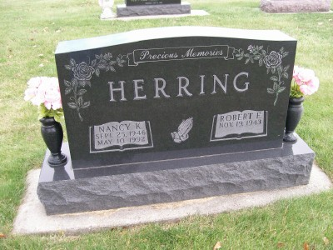
Photo by Barbara Baker Anderson
Robert E. Herring, 74, of Bluffton passed away on Sunday, October 7, 2018, at Lutheran Hospital in Fort Wayne. Bob was born on November 19, 1943 in Marion, Indiana to Clyde & Ruth (Booher) Herring. He attended Jackson High School in Wells Co., worked at Essex Appliance in Van Buren, was employed at CTS in Berne for 20+ years, and retired from Chrysler after 20+ years. In his retirement, he operated a home-based business, Environmental Solutions, for 18 years.
Bob was a member of the Apostolic Christian Church and enjoyed golf, fishing and mushroom hunting. On August 7, 1976, Bob married Nancy K. (Aschliman) and she preceded him in death on May 10, 1992. On September 26, 1993, Bob married Janet M. Morris.
Survivors include his wife Janet “Jan” of Bluffton and 4 children: Bobbie (Mike) Studebaker of Keystone, Beth (Rick) Davis of Montpelier, Bevin (Tina) Herring of Bluffton and Brenna (Barry) Banter of Marion, along with 6 grandchildren and 6 great-grandchildren. He is also survived by siblings: Joyce (Larry) Luckey of Bluffton, Gary (Vicki) Herring of LaFontaine, and Sherri (Don) Carroll of Marion.
Calling hours will be 12 Noon to 8 P.M. on Wednesday (Oct. 10) at the Thoma/Rich, Lemler Funeral Home in Bluffton, and for one hour prior to the funeral service at 10:30 A.M. on Thursday (Oct. 11) at the Apostolic Christian Church East, Bluffton, with Lynn Fiechter and Mark Gerber officiating. Burial will follow at the Apostolic Christian Church Cemetery, Bluffton, Adams County.
Memorials may be made to the family or to the Apostolic Christian Charity Fund.
Funeral arrangements have been entrusted to the care of Thoma/Rich, Lemler Funeral Home in Bluffton.

Thoma/Rich, Lemler Funeral Home, Wells County, IN
October 8, 2018

