Benjamin P. Habegger
June 22, 1927 – September 15, 2016

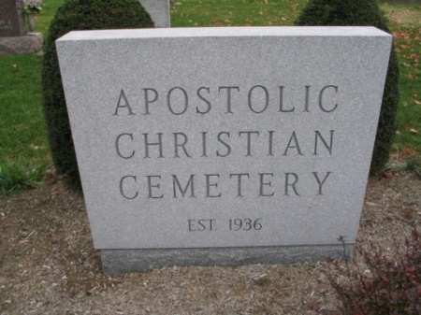
Photo by Barbara Baker Anderson

Benjamin P. “Ben” Habegger, 89, of Bluffton, passed away peacefully Thursday morning, Sept. 15, 2016, at Christian Care Retirement Community in Bluffton.
Born in Adams County on June 22, 1927, to Edgar and Savilla (Roth) Habegger, Ben married Arlene E. Bahler in Remington, IN, on Mar. 20, 1949; she survives.
Ben worked at Mix Mill in Bluffton for 22 years and later at the Wells County Public Library for 14 years. He was also a poultry and grain farmer. He was a member of the Apostolic Christian Church where he held several different church offices. He also volunteered many years at the Apostolic Christian Church Bluffton Distribution Center.
In addition to his wife, Ben is survived by three sons, Sam (Darlene) Habegger of Bluffton, Ted (Jane) Habegger of Poneto, and Tim (Teresa) Habegger of Bluffton; three daughters, Rosemary (Rod) Mounsey of Poneto, Ruby (Doug) Gerber of Bluffton, and Martha Stoller of Decatur; along with 26 grandchildren, 35 great-grandchildren, and one step great-great grandchild. He is also survived by a brother, Alvin (Virginia) Habegger of Decatur; and three sisters, Hannah (Richard) Amstutz of Berne, Catherine Smith of Geneva, and Sarabelle (Robert) Amstutz of Granada Hills, CA.
He was preceded in death by his parents, along with a daughter, Rita Habegger; a grandson, Andrew Habegger; three brothers, Paul, Howard, and Chester Habegger; and a sister, Eldonna Amstutz.
Services will be held Saturday, Sept. 17, 2016, at 10:00 AM, at the Bluffton North Apostolic Christian Church, with ministers of the church officiating. Visitation will be Friday, from 2:00 until 8:00 PM, at Goodwin – Cale & Harnish Memorial Chapel in Bluffton, and Saturday morning, for one hour prior to the service at the church. Burial will be at the Apostolic Christian Cemetery in Adams County. Memorial contributions may be given to Christian Care Retirement Community or Loving Shepherd Ministries.

Goodwin-Cale & Harnish Memorial Chapel, Wells County, Indiana

