Lucy E. Haab
1908 – December 2, 1992

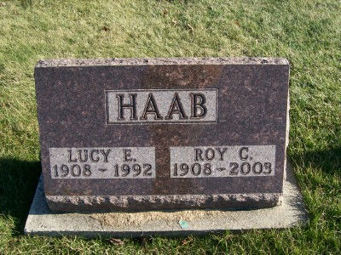
Photo by Scott Shoup
Lucy E Haab, 84, of Bluffton died Wednesday in Caylor-Nickel Medical Center.
Surviving are her husband, Roy C.; and sisters, Nora Gilliom, Dulla Gilliom, Elva Blocker and Violet Isch, all of Bluffton.
Services are 10 a.m. tomorrow in Apostolic Christian Church North, Bluffton, with burial in the church cemetery. Calling continues until 9 tonight in Goodwin Memorial Chapel, Bluffton, and is 9 to 10 a.m. tomorrow in the church.
Preferred memorials are gifts to Christian Care Center.
News-Sentinel, The (Fort Wayne, IN) — Friday, December 4, 1992
Contributed by Jane Edson

