Jacob J. Graber
1897 – March 6,1992

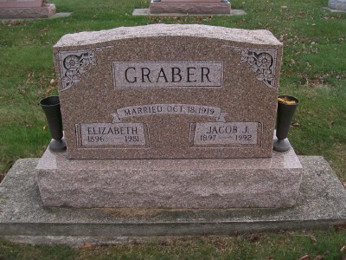
Photo by Scott Shoup
Jacob J. Graber, 95, of Bluffton, died yesterday at Caylor-Nickel Medical Center in Bluffton. He was a retired farmer. His wife, Elizabeth, died in 1981.
Surviving are a son, Glenn of Bluffton; daughters, Pauline Kaehr of Decatur and Betty Steffes of Bluffton; nine grandchildren; and 27 great- grandchildren. Services are 10:30 a.m. Monday at Apostolic Christian Church East, near Bluffton. Calling is 7 to 9 p.m. today and 7 to 9 p.m. tomorrow at Goodwin Memorial Chapel, Bluffton, and an hour before services at the church. Burial will be in the church cemetery.
Preferred memorials are gifts to the Christian Care Center.
News-Sentinel, The (Fort Wayne, IN) — Saturday, March 7, 1992
Contributed by Jane Edson

