Glenn R. Graber
December 11, 1921 – April 19, 2004

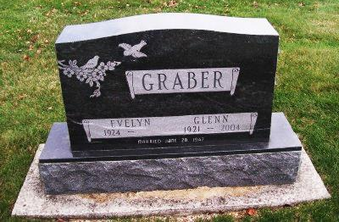
Photo by Scott Shoup
GRABER, GLENN R., Service is 10:30 a.m. today, with visitation one hour prior, at the Apostolic Christian Church East, Bluffton. Arrangements by the Goodwin Memorial Chapel, Bluffton.
Journal Gazette, The (Fort Wayne, IN) — Wednesday, April 21, 2004
Contributed by Jane Edson

