Elizabeth Irene Ginzel
1905 – April 30, 1907

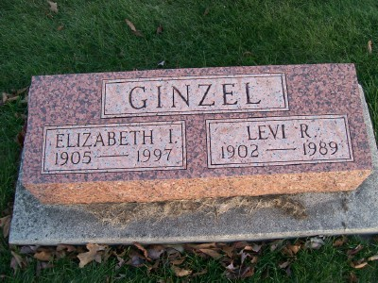
Photo by Scott Shoup
ELIZABETH IRENE GINZEL, 91, died Wednesday in Pontiac, Mich. She was a homemaker. Her husband, Levi R., died in 1989, and a daughter, Sharon Ginzel, also preceded her in death. Surviving are two sons, Byron of Logansport and John of West Bloomfield, Mich.; a daughter, Phyllis Ashinger of Franklin, Mich.; a sister, Queenie Barger of Decatur; eight grandchildren; and five great-grandchildren.
Services at 10:30 a.m. Monday at Apostolic Christian Church, Bluffton. Calling from 2 to 5 and 7 to 9 p.m. Sunday at Elzey & Haggard Funeral Home, and from 9:30 to 10:30 a.m. Monday at the church. Burial in church cemetery. Memorials to the church.
THE OBITUARY IS BEING REPUBLISHED TO PROVIDE ADDITIONAL INFORMATION.
Journal Gazette, The (Fort Wayne, IN) — Friday, May 2, 1997
Contributed by Jane Edson

