Ethel M. Gilliom
1912 – March 2, 2003

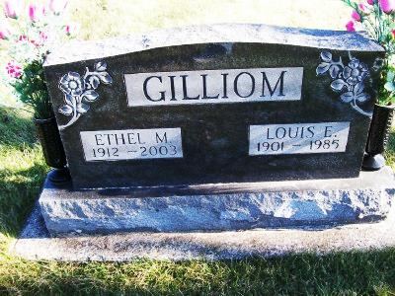
Photo by Scott Shoup
ETHEL M. GILLIOM, 90, died Sunday at Christian Care Retirement Center, Bluffton. Born in Wells County, she was a cook at The Dutch Mill and at Wells Community Hospital. Surviving are her son, David of Bluffton; two daughters, Lorene Brinneman and Linda Geels, both of Temecula, Calif.; a stepson, Kenneth of Bluffton; nine grandchildren; 19 great-grandchildren; and a great-great-grandchild. Services at 2 p.m. Thursday at Bluffton North Apostolic Christian Church, with calling one hour before services. Calling also from 1 to 8 p.m. Wednesday at Goodwin Memorial Chapel, Bluffton. Burial in Apostolic Christian Cemetery, Bluffton. Memorials to Christian Care Retirement Center, Bluffton.
Journal Gazette, The (Fort Wayne, IN) - Tuesday, March 4, 2003
Contributed by Jane Edson

