Loyal W. Geyer
June 14, 1922 – August 5, 1946

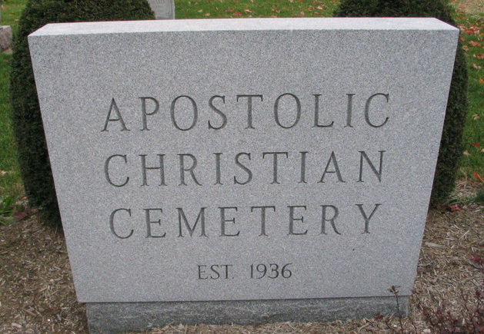
Photo by Barbara Baker Anderson

Handwritten-Mon. Aug. 5, 1946

LOYAL W. GEYER KILLED IN TRAFFIC MISHAP
Returned 24-Year-Old War Vet Dies Instantly; Rites on Wednesday

Loyal W. Geyer, 24, son of Mr. and Mrs. Eli Geyer of St. Mary’s Township, living northeast of Monroe, was instantly killed at 1:45 Monday morning.
Geyer was en route to his home from Frankfort where he had visited his fiancée. The couple had planned to marry on August 19, it was said. The name of the girl was not learned.
Geyer is said to have been driving on the by-path of State Road 37 in Marion corporation limits. He is believed to have fallen asleep (missing) the trailer with such force that it turned the cab around and damaged it badly. The driver of the truck, Benjamin Stubbs, 31, of Detroit, colored, was not injured.
Geyer died instantly from a fractured skull. A piece of wood penetrated his skull.
Geyer was born on June 16, 1922, the son of Eli and Lydia Steffen Geyer. He entered the army November 17, 1942, being inducted at Camp Perry. He was in the ETO for 17 months and was discharged in March of this year at Camp Atterbury.
Surviving are the parents and the following brothers and sisters, all at home: Earl, Verlin, Glen, Lester, George, Lavera, Irene, Berline and Dorothy.
Geyer was a member of the Christian Apostolic Church. The funeral will be held Wednesday afternoon at 2:00 o’clock at the Christian Apostolic Church and burial will be in the church cemetery. The body was removed to the Jahn Funeral Home at Bluffton.

Adams County (IN) Historical Museum
1946 June-Sept Scrapbook

