Fayma R. (Miller) Geyer
April 18, 1926 – September 20, 2010

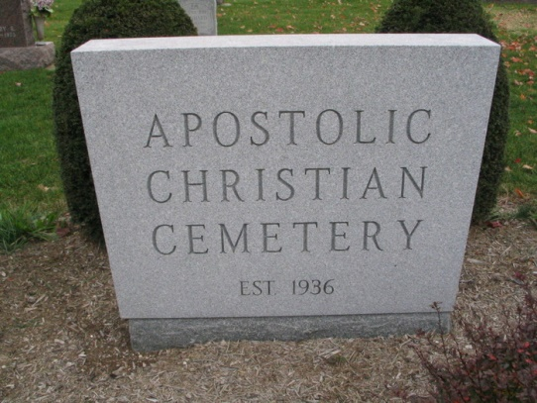
Photo by Barbara Baker Anderson

Fayma R. Geyer, 84 years old of Decatur, Indiana, passed away at 1:15 p.m. on Monday, September 20, 2010 in the Woodcrest Nursing Center located in Decatur, Indiana.
Fayma was born on Sunday, April 18, 1926 in Adams County, Indiana the daughter of the late Chalmer D. Miller and the late Lucille L. (Fleming) Miller. She married the late Earl Geyer on August 31, 1946 in Adams County, Indiana and he passed away on January 5, 1998.
Fayma was a member of the Decatur Church of God; the W.C.G; and a choir member since 1946. She was a graduate of the Pleasant Mills High School Class of 1944. Fayma had been employed with Decatur General Electric for 2 years and Mobile Magnetics in Decatur for 17 years.
Surviving are her daughter, Linda (Dan) Roop of Celina, Ohio; son, Mike D. (Marilyn) Geyer of Monroe, Indiana; son, Kevin E. (Carol) Geyer of Decatur, Indiana; brother, Paul D. (Eileen) Miller of Decatur, Indiana; eleven grandchildren, five greatgrandchildren.
Preceding Fayma in death were one daughter, Beverly Philips; one sister, Boneta Shoaf; three brothers, Don J. Miller, Eugene N. Miller and Chalmer D. Miller Jr.
Funeral services will be held at 11:00 a.m. Thursday, September 23, 2010 in the Decatur Church of God with Dr. Robert Brink officiating. Interment will follow in the Apostolic Christian Cemetery, Vera Cruz, Indiana. Friends will be received from 2-5 and 6-8 p.m. Wednesday, September 22, 2010 in the Zwick and Jahn Funeral Home, Decatur, Indiana and one hour prior to the service at the church on Thursday. Preferred memorials are to Decatur Church of God, or A.C.C.F.-Cancer Fund.

Zwick & Jahn Funeral Home, Adams County, Indiana

