Mary L. (Wagenbach) Gerber
December 25, 1932 – March 14, 2025

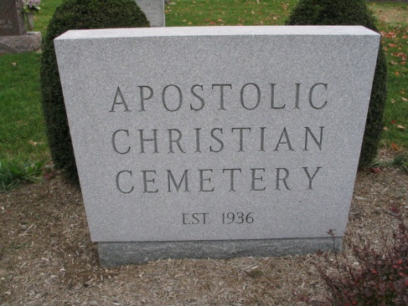
Photo by Barbara Baker Anderson
Mary L. Gerber, 92, of rural Decatur, passed away Friday morning, Mar. 14, 2025, at Stillwater Hospice Home in Fort Wayne. Mary was born in Peoria, IL, on Dec. 25, 1932, to Simon and Louise (Kline) Wagenbach. She married Donald “Don” E. Gerber in Tremont, IL, on Mar. 11, 1956. He preceded her in death on Jan. 1, 2024.
A 1951 graduate of Tremont High School in Illinois, Mary first worked at Caterpillar Inc. in Peoria for a few years before her marriage. She would later hang wallpaper for 30 years with her sister-in-law, Rosemary Gerber, and also stayed at home to raise her four children.
Mary was a member of the Apostolic Christian Church. She enjoyed baking and gardening and especially loved her flowers. She was devoted to her Lord and Savior and will be remembered for her love, kindness, and unwavering commitment to both her family and her faith.
Survivors include three daughters, Deb (Larry) Reinhard of Craigville, Cheryl (Rex) Gerber of Bluffton, and Cindy Gerber of Decatur; a son, Alan (Joli) Gerber of Craigville; 12 grandchildren and 22 great-grandchildren; seven sisters, Carol (John) Steiner of Mediapolis, IA, Jeanette (Fred) Beutel of Tremont, IL, Judy (Vern) Wettstein of Eureka, IL, Helen (Les) Bauman of Eureka, IL, Charlotte (Bill) Metzger of Rock Rapids, IA, Kathy Rocke of Tremont, IL, and Becky (Glen) Bauman of Congerville, IL; and four brothers, James Wagenbach of Tremont, IL, David Wagenbach of Morton, IL, Ron (Liz) Wagenbach of Tremont, IL, and Dale (Mary) Wagenbach of Tolland, CT. She is also survived by two sisters-in-law, LaVonne (Eldon) Getz of Wolcott and Barbara Wagenbach of Tremont, IL; and three brothers-in-law, Roy Schneider of Ellington, CT, James Metzger of Hills, MN, and Jordon Elsasser of Eureka, IL.
In addition to her parents and husband, Mary was preceded in death by three brothers, Robert Wagenbach, Simon Wagenbach Jr., and Steve Wagenbach; four sisters, Joyce Schneider, Shirley Funk, Sharon Elsasser, and Lois Metzger; and four in-laws, Dorothy Wagenbach, Tammy Wagenbach, Virgil Funk, and Nelson Rocke.
Visitation will be Tuesday, Mar. 18, 2025, from 1:00 until 8:00 PM, at Goodwin – Cale & Harnish Memorial Chapel in Bluffton. Services will be Wednesday, Mar. 19, 2025, at 10:30 AM, at the Apostolic Christian Church East, with visitation one hour prior to the service at the church. Chad Gerber and Lynn Fiechter will officiate. Burial will follow at the Apostolic Christian Cemetery in Adams County.
Memorial contributions may be made to Christian Care Retirement Community.
Goodwin Funeral Homes, Wells County, Indiana
March 14, 2025

