Martha E. (Schwartz) Gerber
February 2, 1916 – June 12, 2008
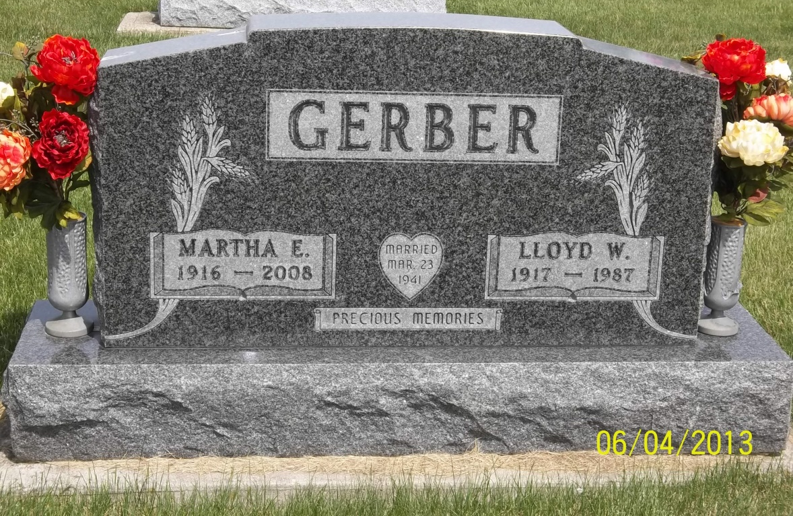
Photo by Danielle Brooks
MARTHA E. GERBER, 92, of Bluffton, passed away Thursday, June 12, 2008, at Christian Care Retirement Center, Bluffton. She is survived by two sons, Arlen (Jeanne) Gerber of Decatur and Neil (Karen) Gerber of Bluffton; and two daughters, Mrs. Dave (Marcene) Gilliom of Bluffton and Mrs. Gary (Diann) Tonner of Decatur. Service is 10:30 a.m. Monday at Apostolic Christian Church East, with viewing one hour prior. Viewing also from 6 to 8 p.m. Saturday and from 1 to 8 p.m. Sunday at Goodwin Memorial Chapel, 3320 E. SR 124, Bluffton. Arrangements by Goodwin Memorial Chapel, Bluffton. Guestbook at www.thegmcfamily.com
News-Sentinel, The (Fort Wayne, IN) - Friday, June 13, 2008
Contributed by Jane Edson

*****FACTS
Born: February 2, 1916 Place of Birth: Wells County, Indiana
Death: June 12, 2008 Place of Death: Christian Care Retirement Community
Occupation: Homemaker & Volunteered at the Christian Care Retirement Community
Organizations: Apostolic Christian Church

SURVIVED BY
Arlen (Jeanne) Gerber, Son Neil (Karen) Gerber, Son
Diann (Gary) Tonner, Daughter Marcene (David ) Gilliom, Daughter
Alice Steffen, Sister Ada (Harry) Gerber, Sister
PRECEDED IN DEATH BY
Levi Schwartz, Father Ida Schwartz, Mother
Edward Schwartz, Brother Harry Schwartz, Brother
Ervin Schwartz, Brother Ralph Schwartz, Brother
Lula Baumgartner, Sister Andy Gilliom, Grandson

Goodwin-Cale & Harnish Memorial Chapel online information (accessed 5/15/2017)

