Frederick W. Gerber

April 10, 1927 – December 24, 1992

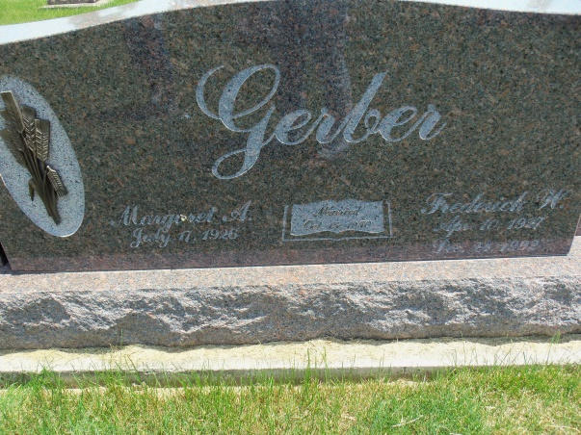

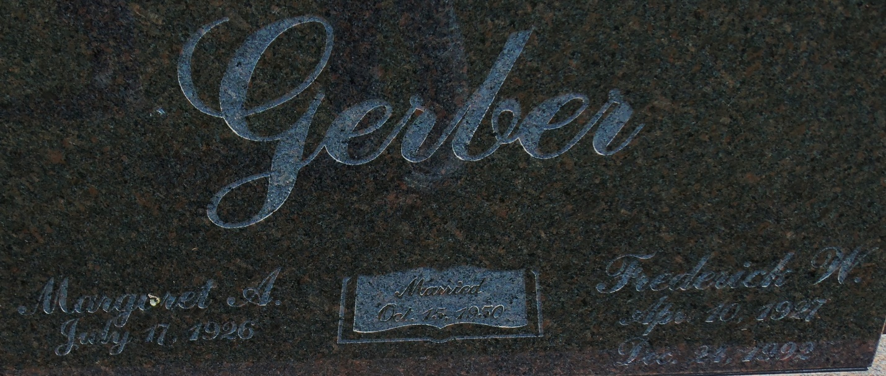

Photo by Danielle Brooks

Frederick W Gerber, 65, of Bluffton died Thursday at Caylor-Nickel Hospital.
He raised poultry and was a farmer.
Surviving are his wife, Margaret; sons, Greg of Bluffton and Gordon of Lafayette; daughters, Myra Zoll of Toledo, Ohio, and Madelyn Clark of Noblesville; brothers, Harry of Bluffton and Wilmer of Decatur; sisters, Marie Kipfer of Bluffton and Devona Longenberger of Monroe; and nine grandchildren. Services will be held at 3 p.m. tomorrow at Apostolic Christian Church East. Calling will be all day today at Goodwin Memorial Chapel and 2 to 3 p.m. tomorrow at the church. Burial will be in the church cemetery.
Preferred memorials are gifts to charity.

News-Sentinel, The (Fort Wayne, IN) — Saturday, December 26, 1992
Contributed by Jane Edson

