Emanuel Lee Gerber
October 19, 1939 – January 8, 2012

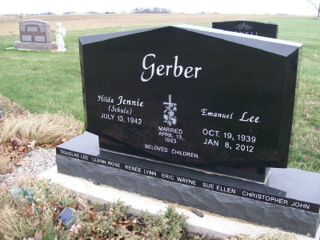
Photo by Scott Shoup

Lee Gerber, 72, of Decatur, died at 8:32 p.m. Sunday, Jan. 8, 2012, at his residence.
Mr. Gerber was born in Adams County on Oct. 19, 1939, to Obed and Leona (Bahler) Gerber. He married Jennie Schulz in San Antoinio, Texas, on April 13, 1963; she survives.
A 1957 graduate of Adams Central, Mr. Gerber was the owner and operator of Lamar Industries. He served in the U.S. Army, with the 2nd Battery of the 35th Artillery in Bamberg, Germany, from 1962 to 1964. He also worked at Adams Central Schools from 1992 to 1996.
Family was a very important part of his life.
Other surviving relatives include three sons, Doug L. (Kristi) Gerber, Eric (Lori) Gerber and Chris (Laura) Gerber, all of Bluffton; two daughters, LeAnn and Renee Gerber, both of Fort Wayne; one sister, Rosetta (Gary) Ringger of Decatur; and seven grandchildren, Darien Lee Gerber, Raegan Gerber, Dalton Lee Gerber, Stockton Lee Gerber, Saela Gerber, Eden Lee Gerber and Addison Gerber.
Mr. Gerber was preceded in death by one daughter, Sue Ellen Gerber, who died on Jan. 31, 1999; one brother, Dean Gerber; one sister, Delilah Gerber; and one grandchild, Phoenix Lee Gerber.
Calling hours will be from 6 to 8 p.m. Wednesday, Jan. 11, and from 1 to 8 p.m. Thursday, Jan. 12, at the Goodwin Memorial Chapel in Bluffton and from 9:30 a.m. Friday at the Apostolic Christian Church East.
Funeral services will be at 10:30 a.m. Friday, at the church with John Reinhard and Ed Schwartz officiating. Burial is at the Apostolic Christian Cemetery. Military rites will be conducted by the Army Honor Guard and American Legion Post 111.
Preferred memorials are to Loving Shepherd Ministries.
Goodwin-Cale & Harnish Memorial Chapel (accessed 5/15/2017)

