Emanuel Gerber
February 27, 1870 – September 5, 1955

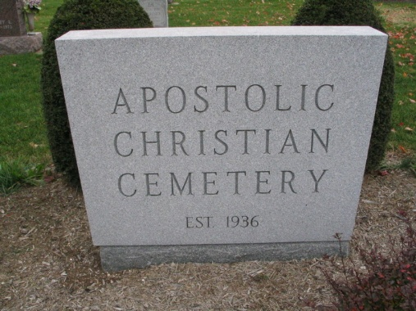
Photo by Barbara Baker Anderson

Emanuel Gerber Claimed by Death

Emanuel Gerber 85, died at 4:15 a.m. Monday at his home in Kirkland Township, Adams County. Death was attributed to complications following an illness of 12 weeks.
Mr. Gerber was born Feb. 27, 1870, in Wells County to Ulrich and Katherine Mathias Gerber. His marriage was to Anna Neuenschwan-der, whose death occurred June 30, 1951.
A retired farmer, he was a member of the Apostolic Christian Church and had resided in Wells and Adams Counties his entire life.
Survivors include six daughters, the Misses Edna, Katie and Josephine Gerber, at home, and Mrs. Walter Pfister, Mrs. Louis Sauder and Mrs. Ray Aeschliman of Adams County; six sons, Homer, Reuben and David Gerber of Wells County, Elmer and Obed Gerber of Adams County and Ray Gerber of Bluffton. Also surviving are two brothers, Gideon and joseph Gerber of Bluffton; a sister, Mrs. Lydia Steffen of Adams County; 31 grandchildren and six great-grandchildren. Four brothers and a sister are deceased.
The body, removed to the Jahn Funeral Home, was taken to the residence where friends may call. Funeral services will be conducted at 1:30 Wednesday afternoon at the residence and at 2 p.m. at the Apostolic Christian Church. Burial will be in the church cemetery.

Unknown newspaper clipping
**
Emanuel Gerber

Emanuel Gerber was born on February 27, 1870 in Adams County, Indiana. He married Anna Neuenschwander (1872-1951) on January 7, 1894. They lived in Kirkland Township, Adams County, Indiana. Emanuel is the father of Enda, Katie, Josephine, Judith, Homer, Lucinda, Rubin, Elmer, Raymond, Obed, David, Ida, and Alice. Mr. Gerber worked and lived on a farm his whole life in Decatur, Indiana. That same house was passed down two generations to his son and his son's son, Eric Gerber, who sold it in 2006. Emanuel and his wife also survived the great depression. He later died September 5, 1955.

SOURCES:
Baumgartner , John. The First One Hundred Years. 1st Edition. Bluffton, Indiana: 1970. 230-231. Print.
The Emanuel Gerber Family updated September 2010 compiled by Milt and Pat Gerber. Genealogy of Casper Gerber 1536-2000. Cederville.

