Edward H. Gerber
March 17, 1922 – April 1, 2012
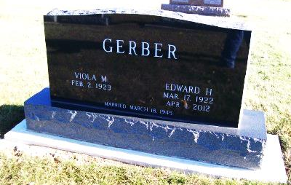
Photo by Scott Shoup

Edward H. Gerber, 90, of Fort Lauderdale, FL went to be with the Lord at 5:25 a.m. Sunday April 1st, 2012 in his home.
Ed enjoyed life, especially spending time with his family. He was always eager to learn about the world and meet new people. He enjoyed travelling with his wife, family, and friends. He was a member of the Apostolic Christian Church of Fort Lauderdale.
Ed started Gerber Furniture in Bluffton, IN in 1946 along with his brother Alvin. He also established the Gerber Haus Motor Hotel in Fort Wayne, developed land in the Fort Lauderdale area, and was in the Florida citrus business for 42 years.
Ed was born March 17th, 1922 in Adams County, IN to Jehu W. and Lydia (Maller) Gerber, the third youngest of sixteen children. He married Viola M. Isch on March 18th, 1945 in Bluffton, IN; she survives. Also surviving are two daughters, Faye (Mike) Hohulin, and Sue (Sid) Troxel, both of Fort Lauderdale; five grandchildren Andrew (Amy) Hohulin, Tara (David) Prevo, Andrea Troxel (engaged to Tyler Geer), Marisa Troxel, and Megan Troxel; two brothers, Sylven and Floyd Gerber of Bluffton IN; and four sisters, Anna Isch, Leona Schwartz, Alice Schwartz, and Josephine Schwartz also of Bluffton.
Ed was also preceded in death by five brothers Gaius, Alvin, Lloyd, Truman, and infant twin Edwin Gerber; and four sisters Helen Gerber, Minnie Aschliman, Sarah Kipfer, and infant Dorothy Gerber.
Calling hours will be from 2 to 8 p.m. Thursday, April 5th at the Goodwin Memorial Chapel in Bluffton, IN and from 9:30 to 10:30 a.m. Friday April 6th at the Apostolic Christian Church East. Funeral services will be at 10:30 a.m. Friday at the church with Mark Gerber and Ed Schwartz officiating. Burial is at the Apostolic Christian Cemetery.

Goodwin-Cale & Harnish Memorial Chapel online obit (accessed 3/10/2017)

