Clara M. (Baumgartner) Gerber
November 19, 1925 – January 1, 2011
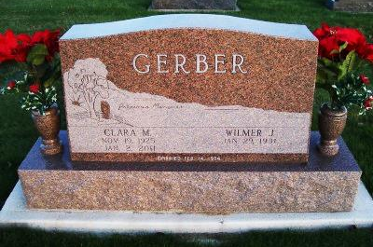
Photo by Scott Shoup

Clara M. Gerber, 85, Bluffton, died at 12:08 a.m. Sunday, January 2, 2011 at the Christian Care Retirement Community.
Born in Adams County on Nov. 19, 1925 to Sam H. and Emma (Fiechter) Baumgartner, she married Wilmer J. Gerber on Feb. 14, 1954 in Bluffton; he survives.
Mrs. Gerber was a housewife and assisted her husband on their farm. She was a volunteer at Christian Care for more than 20 years and also loved gardening.
She was a member of the Apostolic Christian Church.
Other survivors include a son, Darryl (Jinny) Gerber; two sisters, Lucinda
(Ralph) Steffen and Lorine Baumgartner, both of Bluffton; and three grandchildren, Aaron, David and Philip Gerber.
She was preceded in death by a sister, Beulah Baumgartner, and two brothers, Glen and Raymond Baumgartner.
Services will be held Wednesday at 10:30 a.m. at the Apostolic Christian Church East with Mark Gerber and Nile Bucher officiating. Calling hours are Tuesday from 1 to 8 p.m. at the Goodwin Memorial Chapel, 3220 E SR 124, Bluffton, and for one hour prior to the service on Wednesday at the church. Burial will be in the Apostolic Christian Cemetery.
Preferred memorials are to Christian Care Retirement Community.

Goodwin-Cale & Harnish Memorial Chapel online obit (accessed 3/10/2017)

