Anna Melinda (Cowens) Gerber
November 27, 1955 – March 21, 1993

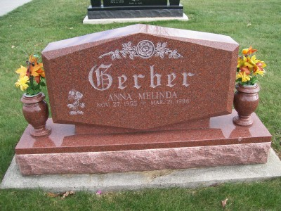
Photo by Scott Shoup

ANNA MELINDA GERBER, 42, died Saturday at Caylor-Nickel Medical Center. Born in Wells County, she worked at Lutheran Hospital, Fort Wayne, for 13 years, and was a migrant school nurse. She was recently a substitute nurse and substitute teacher in Wells County schools.
Surviving are her husband, Scott; two sons, Mick and Benjamin, both at home; a daughter, Alicia Gerber at home; her parents, John W. and Floy L. Cowens of Milford; a brother, John W. Cowens of Grand Pass, Ore.; and a sister, Deborah Landrum of Warren.
Services at 10:30 a.m. Wednesday at Apostolic Christian Church East. Calling from 6 to 9 p.m. today and from 10 a.m. to 9 p.m. Tuesday at Goodwin Memorial Chapel. Calling also an hour before services at the church. Burial in the church cemetery.

Unknown source

