Alice Margaret (Heyerly) Gerber

February 9, 1912 – May 4, 1993

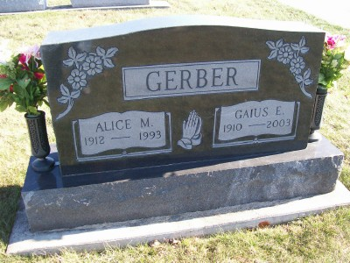

Photo by Scott Shoup

Alice M. Gerber, 81, of Bluffton died Tuesday in Caylor-Nickel Medical Center.
Surviving are her husband, Gaius ; sons, Harry T., Larry W. and Dale L., all of Bluffton; sisters, Ada Berger, Gladys Gerber, Dulla Heyerly, Rosella Heyerly, Bernice Maller and Jeanette Tonner, all of Bluffton; brothers, Herman Heyerly, Homer Heyerly, Raymond Heyerly, Simon Heyerly and Luster Heyerly, all of Bluffton, and Clifford Heyerly of Decatur; 10 grandchildren; and 18 great- grandchildren.
Services are 10:30 a.m. tomorrow in Apostolic Christian Church East, Bluffton, with burial in the church cemetery. Calling continues until 9 p.m. tonight in Goodwin Memorial Chapel, Bluffton, and is 9:30 to 10:30 a.m. tomorrow in the church.

News-Sentinel, The (Fort Wayne, IN) — Thursday, May 6, 1993
Contributed by Jane Edson

