Cassidy Rose Fry
December 22, 2006 – December 22, 2006

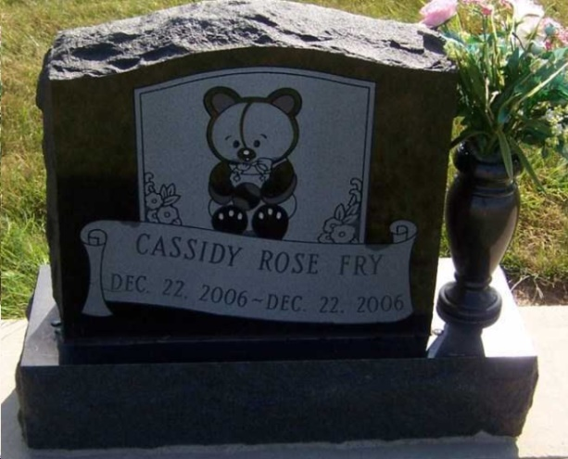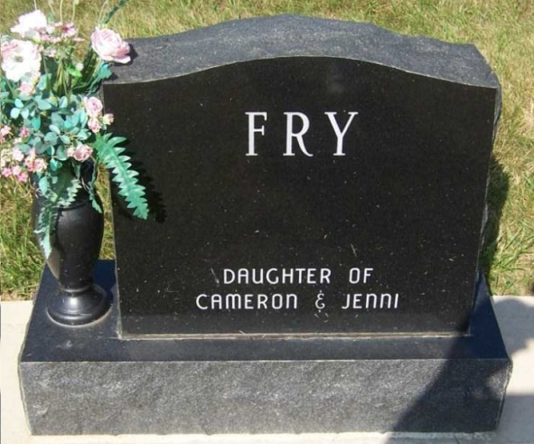
Photos by Pretty Little Grave Seekers

Indiana, Death Certificates, 1899-2011

Name: Cassiday Rose Fry
Gender: Female
Race: White
Age: 0
Marital status: Single
Birth Date: 22 Dec 2006
Birth Place: Indianapolis, Indiana
Death Date: 22 Dec 2006
Death Place: Indianapolis, Marion, Indiana, USA
Father: Cameron Fry, informant
Mother: Jennie Frauhiger
Burial: December 28, 2006; Apostolic Christian Cemetery

