Herbert M. Frauhiger
September 2, 1918 – July 2, 2001

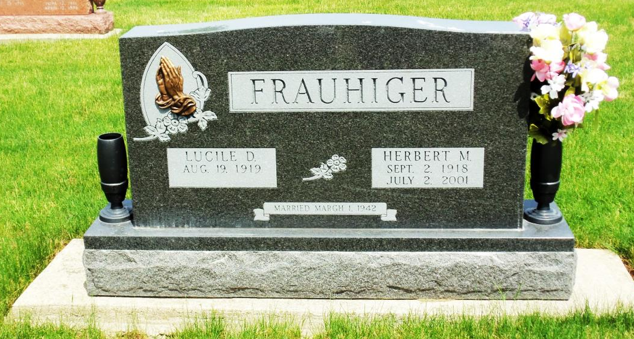
Photo by Danielle Brooks

Herbert M. Frauhiger, 82, of Bluffton, a member of Apostolic Christian Church, died Monday, July 2, 2001, at Christian Care Center.
The Wells County native was a farmer and a former Wells County councilman.
Surviving are his wife, Lucile D.; sons Lester of Decatur and Lonnie G. of Zionsville; a daughter, Beverly Miner of Fort Wayne; a brother, Tom of Bluffton; sisters Mildred Gerber and Marge Ringger, both of Bluffton, and Rose Ringger of Berne; 13 grandchildren; and six great-grandchildren.
Services are 10:30 a.m. Wednesday at Apostolic Christian Church East, Bluffton. Calling is from noon to 9 p.m. today at Goodwin Memorial Chapel, Bluffton. Burial will be at Apostolic Christian Cemetery. Memorials are to Christian Care Retirement Center or Alzheimer's Association.
Information provided by Goodwin Memorial Chapel, Bluffton, 1-219-824-3852.

News-Sentinel, The (Allen County, IN)
Tuesday, July 3, 2001
*****

Indiana, Death Certificates, 1899-2011
Name: Herbert M Frauhiger
Gender: Male
Race: White
Age: 82
Marital status: Married
Birth Date: 2 Sep 1918
Birth Place: Wells Co, In
Death Date: 2 Jul 2001
Death Place: Bluffton, Wells, Indiana, USA
Father: John H Frauhiger
Mother: Olga Speheger
Spouse: Lucie D Isch Frauhiger, informant
Burial: Apostolic Christian Cemetery July 4, 2001

