John Fiechter Sr.
June 27, 1859 – June 10, 1947

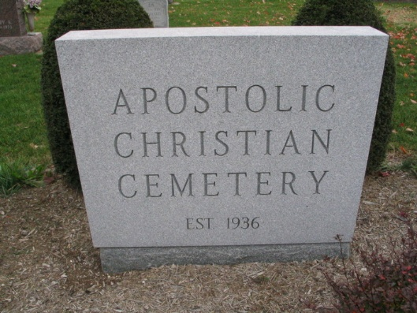
Photo by Barbara Baker Anderson
JOHN FIECHTER, 87, DIES TUESDAY
FUNERAL FRIDAY FOR WELL KNOWN WELLS COUNTY FARMER

John Fiechter, 87, pioneer and prominent Wells County farmer, living a mile and a half south of Craigville, died at 7:30 o'clock Tuesday evening at the Bluffton Clinic Hospital. He was the grandfather of Mrs. Tilman Bauman of Berne and was well known here. Death was caused by bronchial pneumonia. He had been ill four months and in the hospital for a number of weeks.
Mr. Fiechter was born in Wayne County, Ohio, the son of Andrew and Mary Weyerman Fiechter. He was married to Lena Reinhard of Wells County, who preceded in death January 21, 1942. The were married February 25, 1884. Mr. Fiechter had resided in Wells County for 75 years. He was a member of the Apostolic Christian Church.
Surviving are four sons, William of Bluffton, John J, Joel and David, Craigville, and Dan, Decatur; seven daughters, Mrs. William Frauhiger, Mrs. Cornelius Baumgartner, and Mrs. Sam Baumgartner of Bluffton, Mrs. Alma Smith of Fort Wayne, Mrs. Glenn Barger of Craigville, Mrs. Levi Ginzel, Ossian, and Mrs. Jessie S ??, Van Wert, O.; 70 grandchildren, 20 great-grandchildren and a half-brother, Daniel P. Gerber, Fort Wayne. Three sisters and a half-sister preceded in death. They were Mrs. Caroline Dubach, Mrs. ??, Mrs. Ed. Meyer and Mrs. Mary Tschantz.
The funeral will be held Friday at 9:30 a.m. at the home and at 10 o'clock at the church. Burial will be in the church cemetery. The body will be removed to the residence from the Jahn Funeral Home at Bluffton.

Adams County Indiana Historical Museum
1947May-Sep Scrapbook, Image 25
Handwritten-Wed. June 11, 1947
**
John J. Fiechter

John J. Fiechter is the son of Andres and Maria (Wierman) Fiechter. John was born on June 27, 1859. John was 12 when his mom got remarried to a guy named Peter [Gerber]. When she remarried John got loaned to another family so that he could earn his keep. He was a great student.
They had many Swiss neighbors who would bring their cow’s milk over for Peter and Anna Marie to make cheese with. Peter would travel to Ft. Wayne to sell his cheese. He didn’t speak English well, so he would bring John along with him to translate. John later carried on the cheese making business. The cheese is now known as the famous Swiss Cheese.
John was very smart in matters of land and farming. He bought many acres of land and he would build buildings and farm on his new land. John met a young lady named Lena Reinhart. They got married on February 26, 1884. They lived in a house on the frontier and made a living by selling cheese. They had 13 kids: Bertha 1885-1955, Fred 1886-1941, William 1887-1974, John J. Jr. 1890-1974, Joel 1892-1988, Fannie 1894-1970, Emma 1896-1992, Alma 1898-1993, David 1899-1958, Daniel 1901-1970, Queenie Helena January 1905, Elizabeth Irene May 1905, Lillian 1907-1984. They were members of the Apostolic Church. Lena died on January 22, 1942 and John J Sr. died on June 10, 1947.

Baumgartner, John. The First One Hundred Years. 1st ed. Bluffton: 1970. 218-219. Print.
Reinhard, Jerome. Email interview by Maria Wemhoff. Oct. 2013
Fiechter, Stacey. Personal interview by Sarah Fiechter. 14 Oct. 2013.

