Mary Lou (Beutel) Eisenmann
November 16, 1929 – November 27, 2004

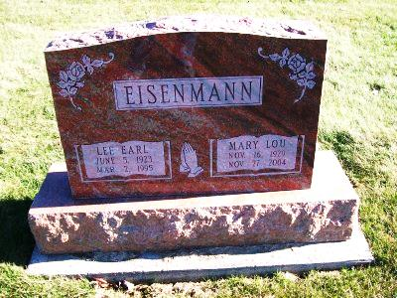
Photo by Scott Shoup
EISENMANN, MARY L. (BEUTEL), Service is 10:30 a.m. today at Apostolic Christian Church, Latty, Ohio, with calling one hour prior to service. Arrangements by D.O. McComb & Sons Maplewood Park Funeral Home, 4017 Maplecrest Road.
Journal Gazette, The (Fort Wayne, IN) — Tuesday, November 30, 2004
Contributed by Jane Edson

