Lee Earl Eisenmann

June 5, 1923 – March 2, 1995

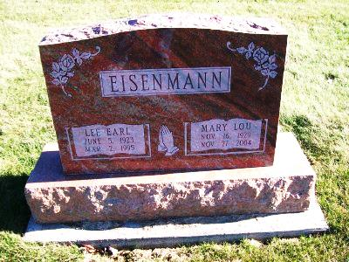

Photo by Scott Shoup

Lee E Eisenmann, 71, of Fort Wayne died yesterday at home.
The Cissna Park, Ill., native was a veteran of World War II, retired in 1985 from International Harvester Co. after 30 years and was a member of Apostolic Christian Church, Latty, Ohio.
Surviving are his wife, Mary L.; daughters, Joyce M. Eisenmann of Fort Wayne and Rosemary L. Larson of Oakville, Iowa; a son, William L. of Woodburn; sisters, Mabel I. Miller of Gridley, Ill., Helen M. Schafer of Hancock, Minn., and Grace A. Heinold of Kouts; brothers, Jess C. of Peoria, Ill., Raymond H. of Cissna Park and Willis A. of Toledo, Ohio; and four grandchildren.
Services are 1 p.m. Sunday in the church. Calling is 1 to 4:30 and 6 to 9 p.m. tomorrow in D.O. McComb & Sons Maplewood Park Funeral Home, 4017 Maplecrest Road, and noon to 1 p.m. Sunday in the church. Graveside services are 4 p.m. Sunday in Apostolic Christian Church Cemetery, Bluffton.

News-Sentinel, The (Fort Wayne, IN) — Friday, March 3, 1995
Contributed by Jane Edson

