Henry G. Dotterer
May 22, 1888 – May 2, 1956

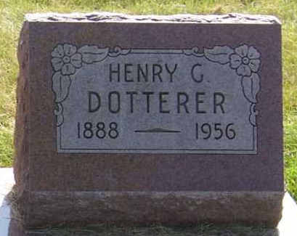
Photo by PLGS
Rev. Henry G. Dotterer Dies Early Today
Funeral Sunday for Minister, Feed and Seed Merchant
Rev. Henry G. Dotterer, 67, one of the ministers of the Apostolic Christian Church northwest of Berne and a Bluffton seed and feed dealer for many years, died at 7:00 a.m. today in the Clinic Hospital at Bluffton. Rev. Dotterer resided at 320 East Market Street, Bluffton.
Death followed an illness of four months. Rev. Dotterer suffered a stroke some time ago and his condition gradually became more serious. He was active in the ministry at the church as long as his health permitted. He resided in Bluffton for 43 years and operated a retail seed and feed store there for many years.
He was born in Paulding County, Ohio, May 22, 1888, the son of Rev. Henry C. and Lydia Steiner Dotterer. He was married to May Reineck at Paulding, Ohio.
Surviving in addition to the wife are two sons, Joseph and Paul Dotterer, both of Bluffton; two daughters, Mrs. Earl (Marjorie) Stucky, Monroe and Mrs. Harry (Caroline) Lantz, Bluffton; eight grandchildren and the following sisters and brothers; Mrs. Mary Kaidel, Cisssna Park, Ill.; Mrs. Anna Manz, Mrs. Martha Laukhof and Isaac and Andrew Dotterer, all of Paulding, Ohio; Mrs. Lydia Sabo, Sarah, Caroline and Ben Dotterer, all of Mansfield, Ohio. A brother, Rev. Elias Dotterer, and a sister, Elizabeth Dotterer, are deceased.
The body is at the Jahn, Goodwin and Reed Funeral Home in Bluffton where friends may call after 7:00 p.m. Thursday. Services will be held Sunday at 1:00 p.m. at the Apostolic Christian Church. Burial will be in the church cemetery.
Adams County Historical Museum, Adams County, Indiana
March 1955 – April 1958 Scrapbook, image 45
Handwritten date: Wednesday May 2, 1956
**
Rev. Henry Dotterer Dies This Morning
Funeral Services Sunday Afternoon
The Rev. Henry G. Dotterer, 67, a minister at the Apostolic Christian Church, died at 7 o’clock this morning at the Clinic Hospital in Bluffton, following an Illness of four months. He was born in Paulding County, O., May 22, 1888, a son of Henry C. and Lydia Steiner-Dotterer, and had lived in Bluffton and Wells County for 43 years. He had operated a feed and seed store in that city for many years.
Surviving is his wife, the former Mary Reineck; two sons, Joe Dotterer of Rural Route 4, Bluffton, and Paul Dotterer of Bluffton; two daughters, Mrs. Earl Stucky of Monroe and Mrs. Harry Lantz of Bluffton; eight grandchildren; three brothers, Isaac Dotterer and the Rev. Andrew Dotterer, both of Paulding, and Ben Dotterer of Mansfield, O.; and six sisters. Mrs. Mary Keidel of Cissna Park, Ill., Mrs. Anna Manz and Mrs. Martha Saukhuf, both of Paulding, Miss Sarah Dotterer, Miss Caroline Dotterer and Mrs. Lydia Sabo, all of Mansfield. One brother and one sister are deceased.
Funeral services will be conducted at 1 p.m. Sunday at the Jahn, Goodwin and Reed Funeral Home at Bluffton, and at 1:30 p.m. at the Apostolic Christian Church. Burial will be in the church cemetery. Friends may call at the funeral home after 7 p.m. Thursday until time of the services.
Decatur Daily Democrat, Adams County, Indiana
Wednesday, May 2, 1956

