Douglas L. Dailey
January 21, 1959 – March 15, 2016

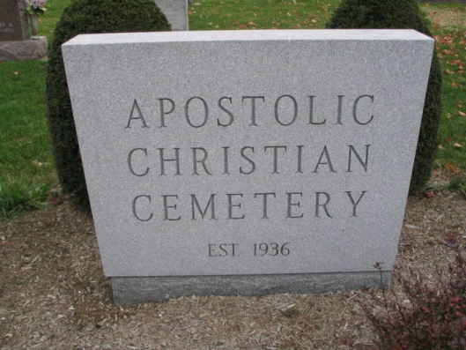
Photo by Barbara Baker Anderson

Douglas L. Dailey, 57, of Bluffton, passed away Tuesday, March 15, 2016, at Bluffton Regional Medical Center after losing his 18-month battle with pancreatic cancer.
He was born Jan. 21, 1959, in Jay County to Donald E. Dailey and Carol J. Everhart Dailey; his mother survives in Berne. He married Susan M. Dotterer in Bluffton June 19, 1977; she survives.
Doug worked in sales at McHenry Knitting from 2007 to 2013. He also worked at Bruce Wholesale Flooring, Redneck Trailer Sales, and at the Butler Bros. Tru-Value store in Bluffton. He graduated from Adams Central High School in 1977 and was a member of the Apostolic Christian Church.
Survivors include a daughter, Stefanie K. (Derrick) Kipfer of Bluffton; two sons, Ben D. (Jackie) Dailey of Bluffton and Kevin L. (Audrey) Dailey of Lafayette; seven grandchildren, Sofie and Lucas Kipfer, Caleb, Lydia and Naomi Dailey, and Cora and Eliza Dailey; a brother, Donald L. (Carol) Dailey; and in-laws, Kathy (Gordon) Gerber, Sally Dotterer and Jeff (Lynn) Dotterer, all of Bluffton.
A service will be held at 10:30 a.m. Friday, March 18, at the Apostolic Christian Church East with Ron Kipfer and Mark Gerber officiating. Calling hours are from 1 p.m. to 8 p.m. Thursday, March 17, at Goodwin-Cale & Harnish Memorial Chapel and at 9:30 a.m. Friday at the church until the time of the service. Burial will be at the Apostolic Christian Cemetery in Adams County. Memorials may be made to WBCL or Family LifeCare in Berne.

Goodwin-Cale & Harnish Memorial Chapel, Wells County, Indiana

