Lucille Mae (Steffen) Borror
November 3, 1926 – May 19, 2008

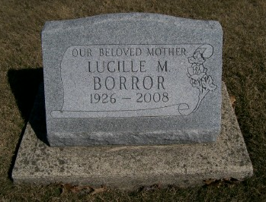
Photo by Scott Shoup

LUCILLE M. BORROR - Obituary
. Former Bluffton resident, Lucille M. Borror, 81, died at 4:10 a.m. Monday, May 19, 2008, at Covington Manor in Fort Wayne.
. Born in Adams County on Nov. 3, 1926 to Tobias and Martha (Baumgartner) Steffen, she was a 1945 graduate of Lancaster High School. She worked as a lab technician at Caylor-Nickel Clinic for five years, and worked for over 20 years at the Dutch Mill Restaurant. She was a member of the Apostolic Christian Church.
. Surviving relatives include a son, Daniel (Nancy) Borror of Fort Wayne; a daughter, Jill (Steve) Bumgarner of Fort Wayne; two brothers, Harry and Kenneth Steffen, both of Bluffton; one sister, Mary Ann (Vernon) Kaehr of Bluffton; four grandchildren and two great-grandchildren.
. Mrs. Borror was preceded in death by one brother, Elmer Steffen, and three sisters, Hilda Robinson, Velma Fulkerson and Norma Eisenman.
. Funeral services will be at 10 a.m. Thursday, at the Bluffton North Apostolic Christian Church. Calling hours will be from 1 to 8 p.m. Wednesday at the Goodwin Memorial Chapel in Bluffton and for one hour
prior to the service at the church. Burial is at the Apostolic Christian Cemetery.
. Preferred memorials are to the American Diabetes Association or Christian Care Retirement Community.
Bluffton (IN) News-Banner, Tuesday, May 20, 2008

