Wayne G. Baumgartner
June 5, 1934 – February 28, 2004
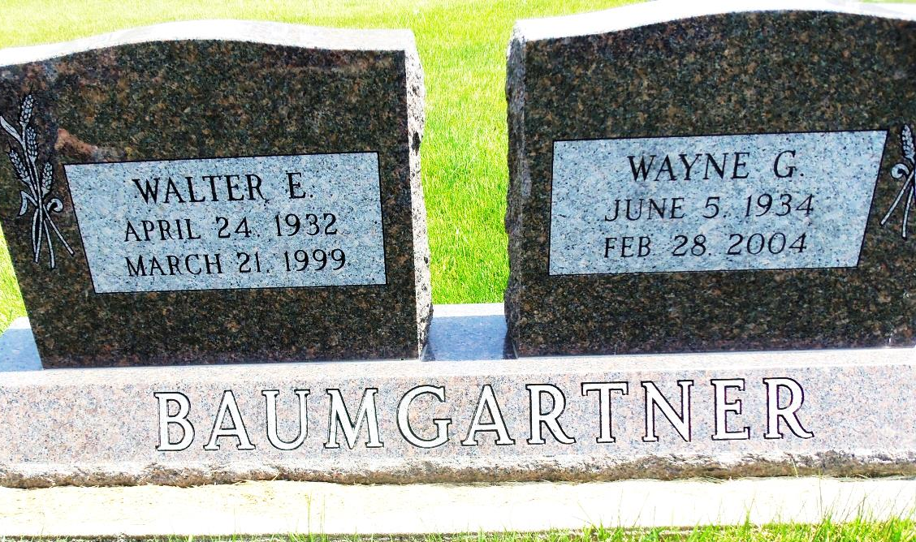
Photo by Danielle Brooks
WAYNE G. BAUMGARTNER, 69, of Coverdale, Ohio, died Saturday, Feb. 28, 2004, at St. Regis Hospital, Lima. Born June 5, 1934, in Adams County, he was the son of Cornelius and Fannie (Fiechter) Baumgartner. Surviving are his brother, Herman Baumgartner of Bluffton; sisters, Mrs. Glenn (Eileen) Furrer of Prescott, Ariz., Mrs. Harold (June) Lehman of Wolcott, Mrs. Harold (Violet) Meyer of Bluffton, Mrs. Robert (Nova) Steffen of Bluffton and Mrs. Rosina Baumgartner of Park Forest, Ill.; two brothers and three sisters. Service is 10:30 a.m. Tuesday at Goodwin Memorial Chapel, Bluffton. Visitation is from 7 to 8 p.m. Monday at the funeral home. Burial at Apostolic Christian Cemetery. Memorials to Christian Care Retirement Community.
News-Sentinel, The (Fort Wayne, IN) - Sunday, February 29, 2004
Contributed by Jane Edson

