Salomett (Steffen) Baumgartner
1865 – September 5, 1940

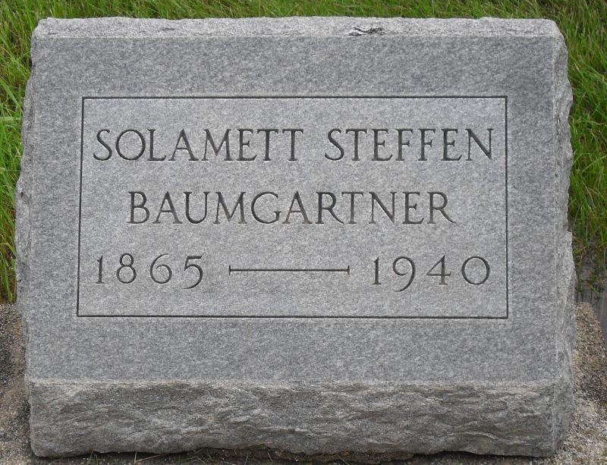
Photo by Stephen & Andrea Brangan

BAUMGARTNER
Bluffton, Sept. 5 – Mrs. Solamett Baumgartner, 75, widow of Joseph Baumgartner, died at 4 am today at the home of Mr. and Mrs. Harry Sharpe, where she had received care during her illness, dating from a fall eight weeks ago. A stroke of paralysis was the immediate cause of death.
Surviving are two sons, John J. Baumgartner of Edgewater, Fla., and Samuel Baumgartner, near Bluffton; three daughters, Mrs. Marion Lee and Mrs. Daniel Steffen of Bluffton and Mrs. Arthur Wolf of New Orange, N.J.; a sister, Mrs. John Moser of Craigville and 10
grandchildren.
Funeral services will be held at 9 am Sunday at the home of the daughter, Mrs. Steffen and at 10 am at the Apostolic Christian Church, east of Bluffton, with burial in the church cemetery.
Journal-Gazette, Allen County, Indiana
September 6, 1940
**

Slomette Steffen, second daughter of John and Magdalene Strahm Steffen was born 1865 in Wells County, Indiana, married Joseph Baumgartner, born 1859, died 1938 (believed to be son of Benedict Baumgartner.) Salomette died in 1940. Both are buried Apostolic Christian Cemetery 1 mile northeast of Vera Cruz, Indiana. Four children listed.

Nicklous Steffen, His Wife, Elizabeth Pfister; Their Children Who Married Into the Aschbaucher, Strahm, Neuenschwander, Lehman, Conrad and Amstutz Families by Lochner, Electa I. Baltzell, p. 121
**

Solamett Steffen Baumgartner from tree Ploof Family Tree

Birth Aug 1865 Wells, Indiana, USA
Marriage 15 Mar 1890 Bluffton, Wells, Indiana, USA
Residence 1 Apr 1940 Bluffton, Wells, Indiana, USA
Death 5 Sep 1940 Wells, Indiana, USA
Father John Steffen (1831-1891)
Mother Magdalena Strahm Steffen (1824-1901)
Spouse Joseph "Joel" Baumgartner (1859-1938)
1888 People 8 Records 17 Sources

