Mildred Marie (Geisel) Baumgartner

1921 – March 2, 1992

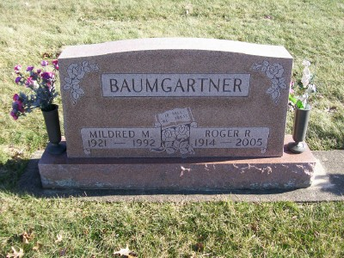

Photo by Scott Shoup

Mildred M. Baumgartner, 70, of Bluffton died Monday in North Collier Hospital, Naples, Fla. Surviving are her husband, Roger; daughters, Polly Gerber and Marilyn Baumgartner; sons, Ralph and Herb; sisters, Delores Maller, Gladys Geisel, Helen Harris and Lorene Geisel; brothers, Harold Geisel, Olen Geisel, Everett Geisel and Vernon Geisel, all of Bluffton; 16 grandchildren; and 15 great- grandchildren.
Services are 10:30 a.m. Saturday in Apostolic Christian Church East, Bluffton, with burial in the church cemetery. Calling is 7 to 9 p.m. today, and 9 a.m. to 9 p.m. Friday in Goodwin Memorial Chapel, Bluffton.

News-Sentinel, The (Fort Wayne, IN) — Wednesday, March 4, 1992
Contributed by Jane Edson

