Keith Nicholas Baumgartner
October 31, 1949 – September 12, 2015

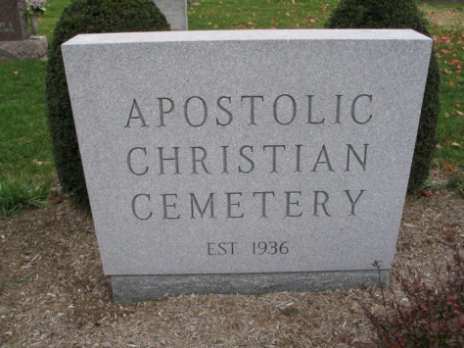
Photo by Barbara Baker Anderson

Keith Nicholas Baumgartner, 65, of rural Bluffton, passed away at 5:03 a.m. Saturday, Sept. 12, 2015, at Visiting Nurse hospice home in Ft. Wayne, from complications related to cancer.
Keith was born in Bluffton on Oct. 31, 1949, to Chet and Betty Baumgartner, his mother survives in Craigville. Keith married Ruth Kipfer on November 9, 1969, in Bluffton, she survives.
A 1967 graduate of Lancaster High School, Keith was a member of the Apostolic Christian Church. He worked as a draftsman for Meyer Building Inc. and enjoyed watching trains and collecting quarters. Keith would always say that his first priority was to God, followed by his wife, then his children.
Keith is also survived by a daughter, Tricia (Dan) Tucker of rural Montpelier; two sons, Nick (Leah) Baumgartner of rural Poneto and Chet Baumgartner of Bluffton; two sisters, Deb (Ted) Neuenschwander and Starla Steckbeck, both of Ft. Wayne; a brother, Bill (Jan) Baumgartner of Leo; and six grandchildren, Timber, Meadow, Juniper and Canyon Tucker, and Rachel and Lydia Baumgartner. Aside from his father, Keith was preceded in death by a brother-in-law, Dr. Robert Steckbeck.
Visitation will be Monday, Sept. 14, 2015, from 5:00 until 8:00 PM at Goodwin – Cale & Harnish Memorial Chapel in Bluffton, and Tuesday, from 1:00 until 8:00 PM, also at the chapel. Services will be Wednesday, at 10:00 AM, at the Apostolic Christian Church East, with one hour of visitation prior to the service at the church. Ron Kipfer and Tim Drayer will officiate. Burial will be at the Apostolic Christian Cemetery. Memorial contributions in Keith’s memory may be given to the donor’s choice.

Goodwin-Cale & Harnish Memorial Chapel online obit
May 3, 2017

