Luella D. (Steffen) Aschliman
1924 – December 28, 1998
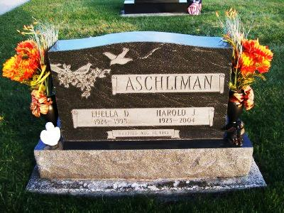
Photo by Scott Shoup

LUELLA D. ASCHLIMAN
BLUFFTON - 1924-1998

Luella D. Aschliman, 74, of Bluffton, a member of Apostolic Christian Church, died Monday, Dec. 28, 1998, at Christian Care Center. The Adams County native was a homemaker and an employee at Dutch Mill Restaurant for 10 years.
Surviving are her husband, Harold; sons Steve of Craigville, and Jon and Bruce, both of Bluffton; daughters Pamela Aschliman of Fort Wayne and Yvonne Myers of Craigville; brothers Leroy, Ramon and Robert G. Steffen, all of Bluffton; a sister, Dina Fae Moser of Bluffton; 15 grandchildren; and five great-grandchildren.
Services are 10:30 a.m. Thursday at Apostolic Christian Church, Bluffton, with calling an hour before services. Calling is also from noon to 9 p.m. today at Goodwin Memorial Chapel. Burial will be in Apostolic Christian Cemetery.
Memorials are to the Christian Care Center Alzheimer's Unit.
Information provided by Goodwin Memorial Chapel, Bluffton, 1-219-824-3852.
News-Sentinel, The (Fort Wayne, IN) - Wednesday, December 30, 1998
Contributed by Jane Edson

